Conversation With ChatGPT:
What If Libraries Became Our Next Civic Superpower?

https://creativecommons.org/licenses/by-nc-sa/4.0/
Attribution-NonCommercial-ShareAlike

(Transcript from the 2026 ChatGPT 5.2 conversation, “--> History of US Libraries”)
Table of Prompts:
Public libraries in America have a long history. Please describe the history in terms of the proponents, politics, and purposes. Include a description of the current status. 2
Describe the history of the Bourse du Travail. 11
In addition to instrumental purposes, these also served as community arts-focused and meeting spaces. Describe, please. 19
Describe how public libraries in America might evolve into some hybrid of the goals and purposes of the Bourse du Travail and the historical evolution of American libraries. 25
Extended, Research-Grounded Reference Set Supporting the Major Themes of Conversation 32
Bibliography 36

Public libraries in America have a long history. Please describe the history in terms of the proponents, politics, and purposes. Include a description of the current status.
Public libraries in the United States reflect a long democratic experiment: Who should have access to knowledge? Who should pay for it? And what purposes should libraries serve? Below is a structured historical narrative—aligned with your interest, Richard, in the civic and political role of knowledge institutions.

I. Origins: Subscription Libraries and Early Republic (1700s–1820s)

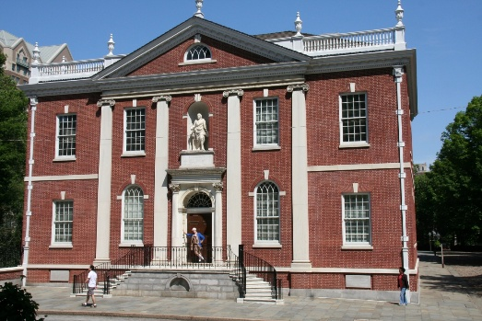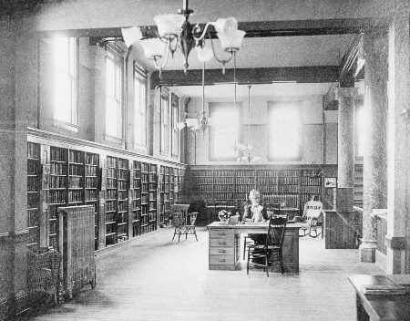

Key Proponents
- Benjamin Franklin and civic elites
- Merchant and professional classes
- Enlightenment-influenced reformers
Politics
- Rooted in republican civic virtue
- Knowledge seen as necessary for self-governance
- Access was not universal—membership fees limited participation
Purposes
- Self-improvement for the educated classes
- Support for commerce and practical knowledge
- Moral and intellectual refinement
Structural Reality
These were typically subscription libraries (e.g., the Library Company of Philadelphia, 1731). They were public in spirit but private in access.
Your broader theme connection:
This phase reflects what you often identify as the proto-liberal education ideal—but still embedded in class hierarchy.

II. The Common School & Free Public Library Movement (1830s–1890s)
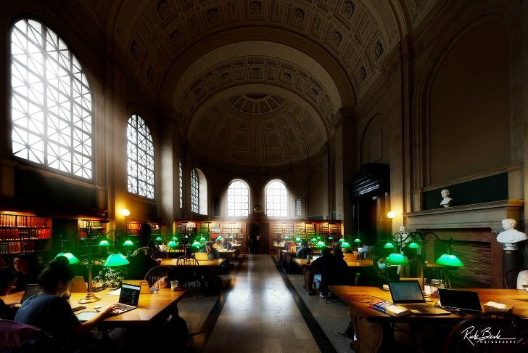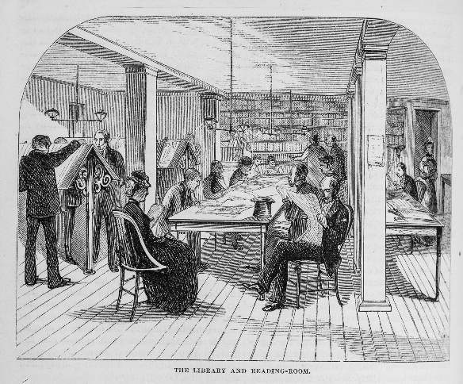

Key Proponents
- Horace Mann (common school movement)
- Urban reformers
- Women’s clubs and civic associations
- Andrew Carnegie (mass library philanthropy)
Politics
This period is crucial.
Competing ideological strands
1. Democratic uplift
- Libraries as engines of citizenship
- Support for immigrant assimilation
- Linked to expanding suffrage
2. Social control
- Elite concern about urban disorder
- Desire to shape working-class culture
- “Improve” immigrant populations
Both were real and intertwined.
Major Institutional Milestone
- Boston Public Library (1854) — first large free municipal library
Purposes
- Universal access to books
- Moral improvement
- Workforce discipline and self-help
- Americanization of immigrants
Carnegie Effect (1883–1929)
Carnegie funded ~1,689 U.S. libraries.

Carnegie model requirements:
- Community must provide land
- Municipality must commit tax support
- Free access required
👉 This created the modern tax-supported public library system.
Your critical lens connection:
Libraries here functioned both as Freirean possibility spaces and as soft assimilation infrastructure—a dual role worth foregrounding in your educational materials.

III. Progressive Era Professionalization (1890s–1930s)
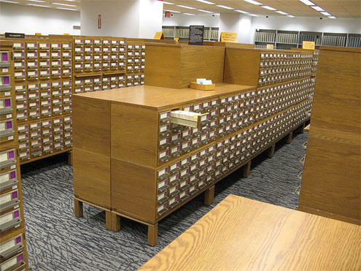
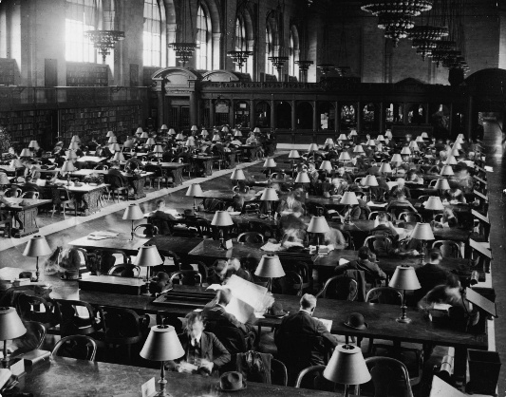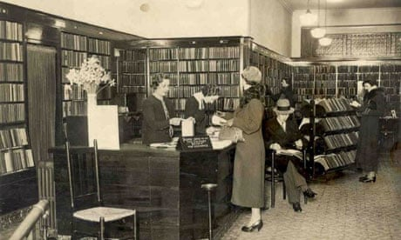
Key Proponents
- Melvil Dewey (professionalization)
- American Library Association (ALA)
- Progressive reformers
- Women librarians (a major workforce)
Politics
- Progressive faith in expert administration
- Scientific management applied to knowledge
- Libraries framed as neutral civic institutions
But neutrality was partly mythic.
Hidden politics
- Collection decisions shaped culture
- Censorship battles emerged
- Segregated libraries in the Jim Crow South
Purposes
- Efficient information access
- Children's literacy
- Civic education
- Cultural standardization
Important shift:
Libraries become professional bureaucracies, not just civic reading rooms.

IV. New Deal Through Postwar Expansion (1930s–1960s)
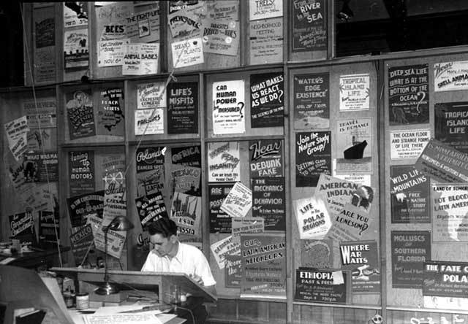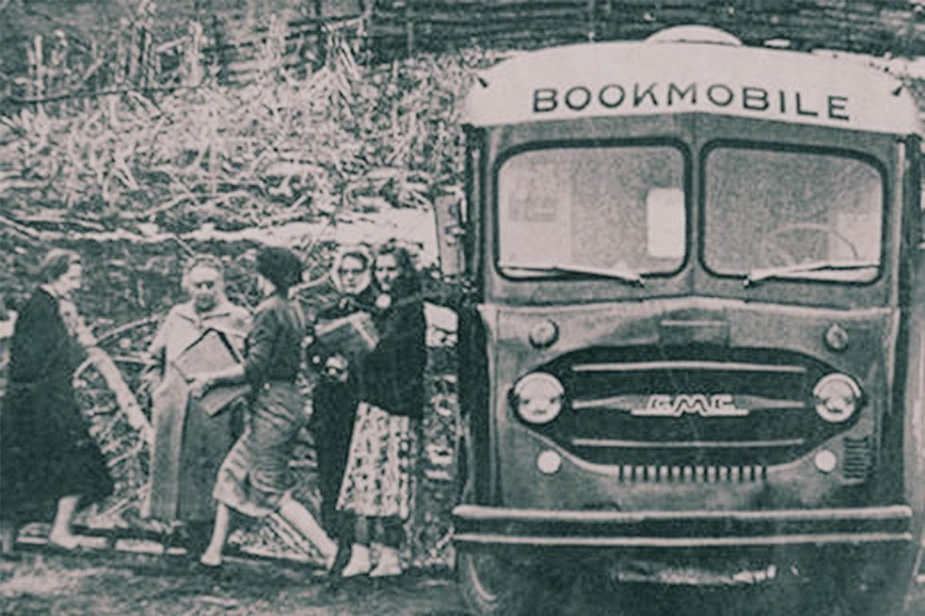

Key Proponents
- Federal government (New Deal programs)
- Works Progress Administration
- Library associations
- Civil rights advocates (later phase)
Politics
- New Deal state-building
- Cold War information competition
- Civil rights pressure for desegregation
Major Policies
- Library Services Act (1956)
- Federal rural library support
- Bookmobile expansion
Purposes
- Rural access
- Workforce education
- Democratic information infrastructure
- Community cultural center

Civil Rights Tensions
- Many Southern libraries segregated into the 1960s
- Libraries became sites of quiet civil rights struggle

V. Late 20th Century: Information Age Transition (1970s–2000s)
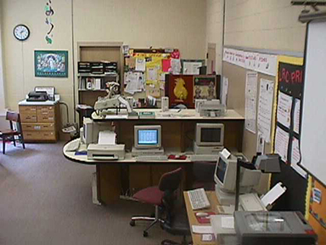
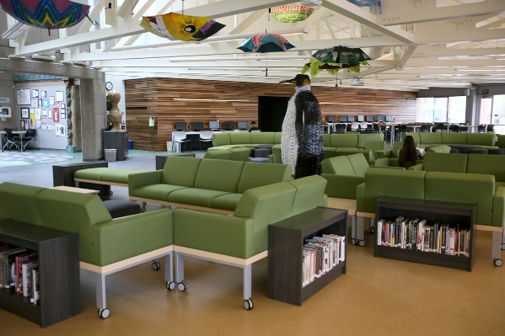
Key Proponents
- Library technologists
- Federal E-rate program advocates
- Community service librarians
- Municipal governments
Politics
- Neoliberal budget pressures
- Rise of digital divide concerns
- Shift from books → information services
Purposes (expanding rapidly)
- Internet access for the public
- Job search assistance
- Digital literacy
- Community programming
- Safe public space
Critical structural shift:
Libraries became the de facto social infrastructure of last resort.
This strongly connects to your ongoing theme of institutional substitution under neoliberalism.

VI. Current Status (2010s–2025): The Hybrid Civic Infrastructure
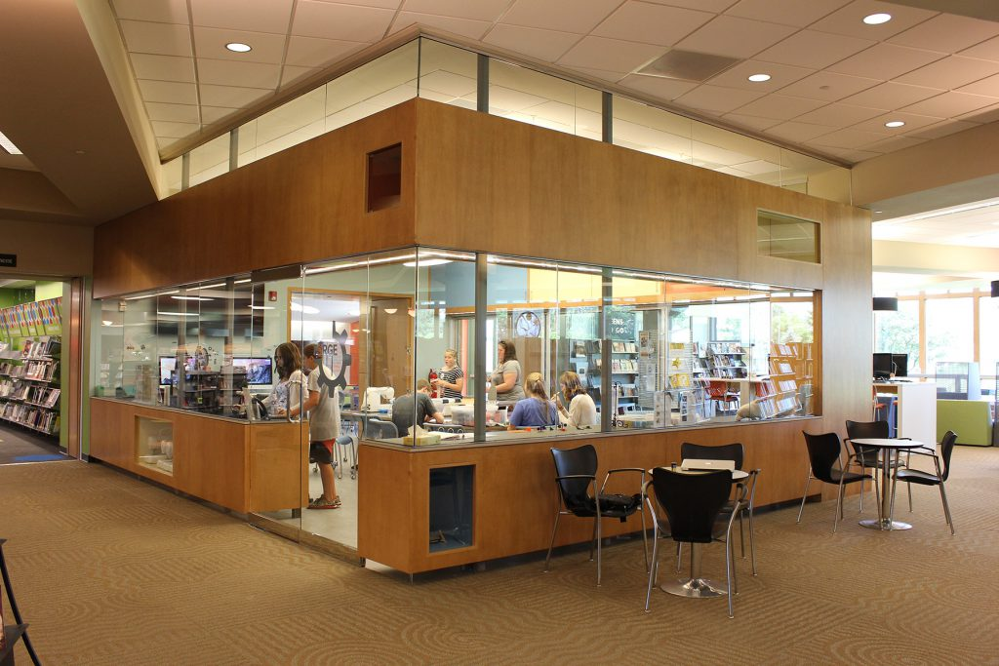

Core Functions Today
1. Information access (still foundational)
- Physical collections
- E-books and databases
- Research assistance
2. Digital equity infrastructure
- Free broadband access
- Device lending
- Tech training
3. Social service front line
Increasingly libraries provide:
- Homeless outreach
- Cooling/warming centers
- Benefits navigation
- ESL programs
- Workforce development
This is a major structural evolution.

Contemporary Political Pressures
A. Book challenges and culture wars
Libraries are again politically contested.
Key issues:
- Intellectual freedom vs parental control
- Local vs state authority
- Curriculum spillover into libraries
B. Funding precarity
- Heavy dependence on local property taxes
- Vulnerable to municipal austerity
- Uneven rural vs urban capacity
C. Platform capitalism pressure (your recurring concern)
Libraries now operate alongside:
- Amazon’s book ecosystem
- Google search dominance
- AI knowledge interfaces
This raises profound questions about the future public knowledge commons.

VII. Structural Interpretation (Aligned with Your Framework)
From your liberal-education and autonomy lens, U.S. public libraries have historically served three overlapping functions:
1. Democratic infrastructure
- Access to knowledge
- Support for citizenship
- Lifelong learning
2. Social stabilization mechanism
- Assimilation of immigrants
- Workforce discipline
- Soft social control
3. Public counterweight to market knowledge systems
Increasingly important in the AI era.

VIII. Future Trajectories (Analytical Outlook)
Based on current trends, libraries are likely to evolve along four axes:
Likely expansions
- AI literacy hubs
- Community learning ecosystems
- Makerspaces and digital production
- Civic dialogue spaces
Major risks
- Chronic underfunding
- Political interference
- Platform enclosure of knowledge
- Mission overload (“everything agency” problem)

Bottom Line
Public libraries in America began as elite self-improvement clubs, became Progressive engines of democratic uplift (and assimilation), evolved into New Deal civic infrastructure, and today function as multifunctional public knowledge and social support hubs under significant political and economic pressure.

Describe the history of the Bourse du Travail.
The Bourse du Travail: History, Politics, and Purpose
The Bourse du Travail (“Labor Exchange”) was one of the most important institutional innovations of the late 19th- and early 20th-century labor movement in France. It functioned simultaneously as a workers’ center, hiring hall, educational hub, and organizing base—and, at its most ambitious, as the embryo of an alternative social order.
Below is a structured historical account aligned with your interest, Richard, in democratic institutions, cooperative alternatives, and worker self-organization.

I. Origins (1870s–1880s): Municipal Reform Meets Labor Organization
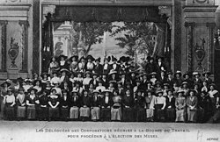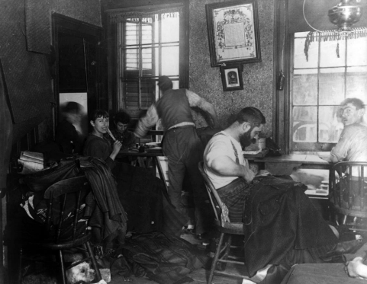
Founding Context
The first Bourse du Travail opened in Paris in 1887, though earlier labor exchanges existed in more limited forms.
Key Drivers
Municipal reformers
- Wanted orderly labor markets
- Sought to reduce unemployment unrest
- Viewed the Bourse as a public employment office
Trade unions and workers
- Saw an opportunity for autonomous organization
- Quickly expanded the institution’s scope
- Used the space for meetings and education
👉 From the beginning, the Bourse had a dual character:
- Administrative tool (state/municipal vision)
- Worker self-organization hub (labor movement vision)

Political Background
The Bourse emerged in the aftermath of:
- The Paris Commune (1871)
- Harsh repression of radical labor movements
- The consolidation of the Third Republic
French authorities hoped partially to channel and domesticate worker unrest—a pattern you often note in institutional design.
But the outcome was more complex.

II. Rapid Expansion and Worker Control (1890s)
Key Proponent
The central figure in the Bourse movement was:
- Fernand Pelloutier — anarcho-syndicalist organizer
Pelloutier’s Vision
Under Pelloutier’s leadership (1895–1901), the Bourses became:
- Centers of worker education
- Nodes of mutual aid
- Bases for general strike preparation
- Laboratories for worker self-management

Institutional Growth
By the late 1890s:
- Dozens of Bourses existed across France
- They were federated into the Fédération des Bourses du Travail (1892)
- They became closely linked with the emerging Confédération Générale du Travail (CGT)

Core Functions
The mature Bourse typically provided:
1. Labor exchange (original function)
- Job matching
- Hiring halls
- Skill registries
2. Worker education
- Technical training
- Political education
- Literacy classes
- Libraries and reading rooms
3. Mutual aid
- Unemployment support
- Travel assistance for job seekers
- Legal aid
4. Organizing infrastructure
- Union meeting space
- Strike coordination
- Inter-trade solidarity

III. The Syndicalist High Point (1895–1914)
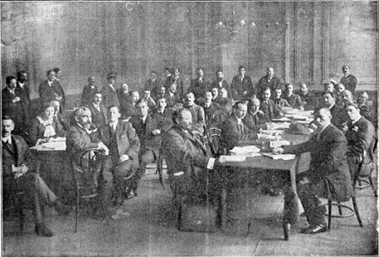
This period represents the golden age of the Bourses.
Political Philosophy: Revolutionary Syndicalism
The Bourses became central to a broader project:
Build the institutions of the new society inside the shell of the old.
This will sound very familiar relative to your cooperative and prefigurative frameworks.
Key Ideas
- Worker self-management
- Anti-parliamentarian socialism
- General strike as transformative event
- Federalist worker networks
- Education for worker autonomy

Why They Mattered Structurally
The Bourse system was radical because it attempted to integrate:
- Labor market coordination
- Worker education
- Mutual aid
- Political organization
Into a single worker-controlled civic infrastructure.
In modern language, they were:
proto-platforms for democratic labor coordination.

IV. Tensions and Limits
Despite their promise, Bourses faced structural constraints.
A. Municipal Dependence
Most Bourses were:
- Funded by municipalities
- Housed in city buildings
- Legally tolerated rather than fully autonomous
This created an enduring contradiction:
Worker autonomy inside state-supported infrastructure.
You will recognize this as a classic institutional tension.

B. Internal Labor Movement Divisions
Conflicts emerged between:
- Revolutionary syndicalists
- Reformist unionists
- Socialist party organizers
- Later, communist factions

C. World War I Disruption
The war (1914–1918):
- Fragmented international labor solidarity
- Drew many workers into national war efforts
- Strengthened the central state
- Weakened revolutionary syndicalism

V. Interwar Transformation and Decline (1920s–1940s)
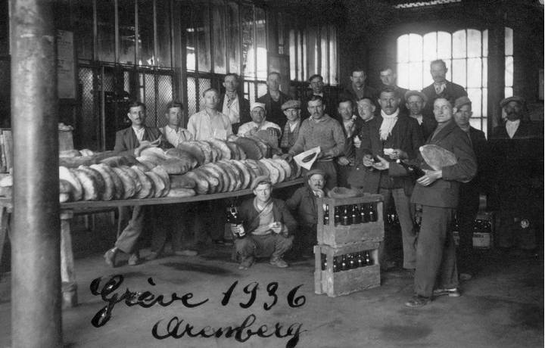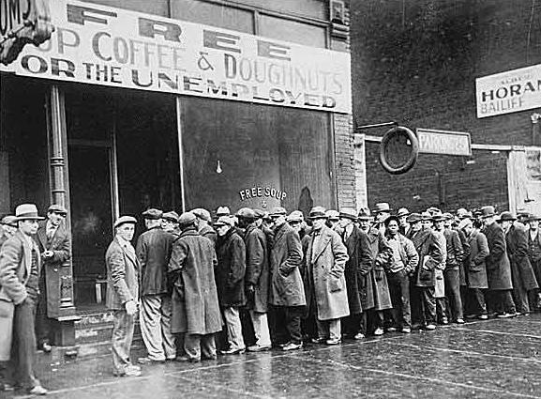
Key Shifts
Over time, many Bourse functions were:
- Absorbed into state employment services
- Professionalized
- Bureaucratized
- Depoliticized
The radical syndicalist vision faded.

Post–World War II
After 1945:
- National labor institutions expanded
- Welfare state structures grew
- Employment services centralized
Many Bourses survived as union buildings or municipal labor offices, but the original transformative ambition diminished.

VI. Current Status
Today, in France:
- Some buildings named Bourse du Travail still exist
- Many function as:
  - union offices
  - meeting halls
  - municipal labor centers
- The original federated revolutionary network is gone
However…
Conceptual Legacy (Very Much Alive)
The Bourse model continues to influence:
- Worker centers
- Hiring halls
- Labor cooperatives
- Platform cooperative proposals
- Solidarity economy movements

VII. Why the Bourse du Travail Matters (Analytical Frame)
Richard, through your cooperative and democratic infrastructure lens, the Bourse represents a historically rare attempt to build what we might call:
integrated worker civic infrastructure
It combined:
- Economic coordination
- Education
- Mutual aid
- Democratic governance
in one institutional form.

Structural Comparison to Today
Function | Bourse du Travail | Modern Equivalent
Job matching | Hiring hall | LinkedIn / Indeed
Worker education | Union schools | Community colleges / MOOCs
Mutual aid | Worker funds | Fragmented nonprofits
Solidarity space | Union hall | Rare / declining
Worker data | Local registries | Platform-controlled data
👉 The key difference:
Bourses were worker-governed.
Modern systems are platform-governed.
This connects directly to your ongoing concerns about platform power and democratic capability.

Bottom Line
The Bourse du Travail began in the 1880s as a municipal labor exchange but was rapidly transformed by anarcho-syndicalists—especially Fernand Pelloutier—into a dense network of worker-run institutions that combined job placement, education, mutual aid, and political organizing. It represented one of the most sophisticated historical attempts to build democratic worker infrastructure inside capitalist society. Although the movement declined after World War I and was gradually absorbed into state and union bureaucracies, its institutional DNA lives on in contemporary cooperative, solidarity-economy, and platform-cooperative experiments.

In addition to instrumental purposes, these also served as community arts-focused and meeting spaces. Describe, please.
Absolutely—this is a crucial and often underemphasized dimension of the Bourse du Travail. While formally created as labor exchanges and union hubs, many Bourses evolved into dense working-class cultural ecosystems. In fact, for syndicalists like Fernand Pelloutier, culture and education were not peripheral—they were essential to building worker autonomy and solidarity.
Below is a structured account aligned with your interest, Richard, in institutions that cultivate civic and critical consciousness.

I. The Cultural Turn: From Hiring Hall to Workers’ Cultural Commons
Pelloutier’s Strategic Insight
Pelloutier and allied organizers believed:
Economic organization alone was insufficient; workers needed intellectual and cultural self-development.
Thus, the Bourse became what we might call today:
- a worker cultural center
- a counter-hegemonic public sphere
- a prefigurative civic institution
This closely parallels your recurring theme: institutions that build the capacities required for democratic self-rule.

II. Arts and Cultural Programming
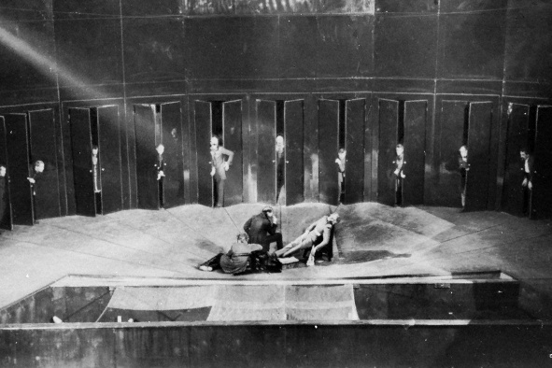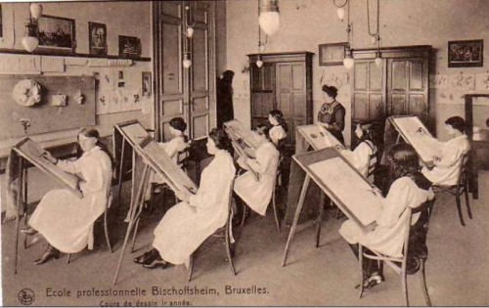

1. Workers’ Theater and Performance
Many Bourses hosted:
- amateur theater troupes
- political drama
- workers’ pageants
- public lectures with dramatic elements
Purposes
Political education
- dramatizing class relations
- making abstract economics concrete
- building class consciousness
Emotional solidarity
- shared experiences
- collective identity formation
Accessible culture
- culture not reserved for bourgeois theaters
👉 In modern terms: experiential civic learning through the arts.

2. Choirs, Music, and Festivals
Bourses frequently supported:
- workers’ choirs
- brass bands
- commemorative events
- May Day cultural festivals
Why this mattered
Music served as:
- memory transmission
- morale building
- movement cohesion
- ritualized solidarity
This is deeply consistent with what you often highlight: affective infrastructure matters as much as cognitive infrastructure.

3. Libraries and Reading Rooms
Many Bourses maintained substantial libraries.
Typical collections included:
- technical manuals
- political economy
- socialist and anarchist literature
- general literature and classics
- newspapers and international labor press
Function beyond information access
These spaces cultivated:
- self-directed learning
- critical reading habits
- cross-trade intellectual exchange
- what we might call today worker epistemic agency

III. Education as Cultural Formation (Not Just Skill Training)
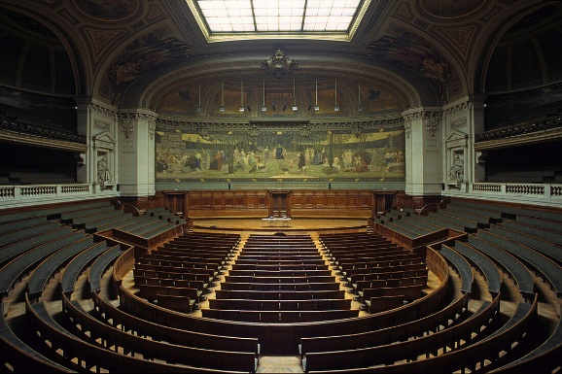
Types of Classes Offered
Beyond vocational training, Bourses offered:
- history
- political economy
- languages
- public speaking
- hygiene and science
- literature
This is strikingly close to liberal education for workers.

Study Circles and Discussion Groups
These were especially important.
Characteristics
- peer-led
- dialogic
- cross-trade participation
- often evening-based
- low or no cost
Cognitive function
They built:
- argumentative capacity
- rhetorical skill
- critical consciousness
- democratic deliberation habits
Richard, this is almost a textbook case of what Paulo Freire would later call conscientização.

IV. The Bourse as a Social and Civic Meeting Space
Physical Infrastructure
Typical Bourses included:
- large assembly halls
- meeting rooms
- classrooms
- libraries
- sometimes cafés or social rooms
These were among the few autonomous public spaces available to working-class people.

Everyday Social Functions
Beyond formal programming, Bourses served as:
- informal gathering spaces
- inter-union coordination hubs
- newcomer orientation sites
- migrant worker support points
- mutual aid coordination centers
They were, functionally:
working-class civic centers

V. Gender and Community Dimensions
An often overlooked feature.
Women’s participation
Though unions were male-dominated, Bourses often hosted:
- women’s educational programs
- family-oriented events
- literacy programs
- social gatherings
Family and community life
Events sometimes included:
- holiday celebrations
- children’s activities
- public lectures open to families
This broadened the Bourse beyond a narrow workplace institution into a community social infrastructure.

VI. Why the Cultural Layer Was Strategically Essential
Syndicalists understood something many modern institutions forget:
Durable worker power requires cultural reproduction, not just economic coordination.
The arts and meeting functions helped produce:
Psychological effects
- dignity
- belonging
- collective efficacy
- moral legitimacy
Cognitive effects
- critical reasoning
- political literacy
- historical awareness
Social effects
- cross-trade solidarity
- trust networks
- movement continuity

VII. Comparison to Modern Institutions (Your Systems Lens)
Function | Bourse du Travail | Modern Fragmented Equivalent
Worker theater | In-house | Rare / nonprofit arts
Study circles | Union-based | Online forums / sporadic
Libraries | Worker-run | Public libraries
Meeting halls | Central | Coworking / rented space
Cultural festivals | Movement-based | Eventized / commercial
Key loss: institutional integration.

Bottom Line
Beyond their instrumental role as labor exchanges, the Bourses du Travail functioned as vibrant working-class cultural commons. They hosted theater, music, libraries, study circles, and public lectures; provided meeting halls and social space; and cultivated the intellectual, emotional, and civic capacities necessary for worker self-organization. In doing so, they anticipated many later theories of critical consciousness and democratic education. Their decline did not eliminate the need they met—it merely fragmented those functions across today’s far more marketized and platform-mediated institutional landscape.

Describe how public libraries in America might evolve into some hybrid of the goals and purposes of the Bourse du Travail and the historical evolution of American libraries.
Richard, this is a rich and timely synthesis. If we read the Bourse du Travail alongside the American public library tradition, a plausible future emerges: the library as a democratic civic infrastructure hub—combining knowledge access, worker support, cultural production, and community self-organization.
Below is a structured evolutionary pathway grounded in institutional history, political economy, and your recurring concern with autonomy under platform power.

I. The Structural Convergence Already Underway
Historically:
- American libraries → information access + civic literacy
- Bourses du Travail → labor coordination + worker culture + mutual aid
Today, U.S. public libraries are already drifting toward Bourse-like functions.
Evidence of Convergence
Libraries now routinely provide:
- Job search assistance
- Resume workshops
- Workforce development
- ESL and citizenship classes
- Makerspaces
- Community meeting rooms
- Social service navigation
👉 In functional terms, many libraries are becoming soft labor and social infrastructure nodes.
But the transformation is incomplete and uneven.

II. What a True Hybrid Model Would Look Like
Think of the future institution as:
The Civic Knowledge and Work Commons
Below are the major functional layers.

1. Information Commons (Historical Library Core)
This remains foundational and should not be lost.
Functions
- Books and archives
- Research assistance
- Digital access
- AI literacy and verification support
- Local knowledge preservation
Why it matters
This is the epistemic infrastructure of democracy—a theme central to your liberal education framework.

2. Work and Economic Navigation Layer (Bourse Legacy)
Here the Bourse influence becomes explicit.
Expanded services
Beyond current job help toward:
- Sector-based hiring halls
- Skills registries
- Worker cooperative incubators
- Freelance and gig navigation support
- Benefits and labor rights counseling
- Portable credential verification
Strategic shift
From:
“Help individuals find jobs”
Toward:
“Help communities coordinate dignified work”
This is a profound institutional pivot.

3. Cultural Production and Community Arts Layer
This is where American libraries could most fruitfully learn from the Bourse tradition.
Potential expansions
- Worker and community theater
- Local media production labs
- Oral history studios
- Community publishing platforms
- Public-interest documentary hubs
- Civic storytelling programs
Why this matters (your lens)
Culture builds:
- identity
- solidarity
- narrative agency
- democratic imagination
Libraries already have the trust infrastructure to host this.

4. Democratic Learning and Critical Capacity Layer
This aligns strongly with AAC&U liberal education outcomes you often reference.
Possible programming
- Structured study circles
- Deliberative forums
- media literacy labs
- AI persuasion literacy
- community research collaboratives
- participatory budgeting support
Key shift
From:
passive information consumption
To:
active civic capability formation

5. Mutual Aid and Social Infrastructure Layer
Libraries are already drifting here—but often without adequate design.
Likely hybrid functions
- benefits navigation
- legal aid clinics
- immigrant support
- housing navigation
- health literacy hubs
- climate resilience centers
The key design question:
How to support without mission overload?

III. Governance: The Critical Design Choice
This is where the Bourse model offers the most important lesson.
Historical contrast
Traditional U.S. library governance
- municipal control
- professional administration
- advisory boards
Bourse governance
- worker federations
- bottom-up participation
- functional representation

Hybrid Governance Model (Most Promising)
A future-ready library could include:
Layered governance
1. Professional librarianship
- collection integrity
- information ethics
- technical systems
2. Community councils
- program priorities
- cultural programming
- local needs assessment
3. Worker and cooperative advisory bodies
- workforce programming
- labor market navigation
- co-op incubation
This preserves expertise while expanding democratic participation.

IV. The AI and Platform Context (Your Recurring Concern)
The urgency of this evolution is rising because of platform concentration.
Without transformation, knowledge ecosystems risk becoming:
- Amazon for books
- Google for information
- LinkedIn/Indeed for work
- AI platforms for cognition
All privately governed.

The hybrid library-Bourse could become:
the last major public alternative infrastructure
Strategic roles
- Public AI literacy and verification
- Community-controlled data commons
- Worker platform cooperatives support
- Algorithmic transparency education
- Digital dignity infrastructure

V. Major Risks and Constraints
Any serious proposal must acknowledge structural limits.
1. Funding fragility
Libraries remain:
- property-tax dependent
- politically vulnerable
- unevenly resourced
A Bourse-like expansion requires:
- state investment
- philanthropic support
- cooperative partnerships

2. Mission overload
Libraries are already experiencing what you might call:
institutional overextension under neoliberal withdrawal.
Without careful design, they risk becoming:
- underfunded everything-centers
- staff burnout zones
- politically contested spaces

3. Political backlash
As libraries become more civically central, they may face:
- culture-war pressures
- labor politics conflicts
- local governance tensions
- platform lobbying pressure

VI. Most Plausible Evolution Path (Realistic Scenario)
Based on current trajectories, the most likely path is incremental hybridization, not wholesale transformation.
Phase 1 (already happening)
- Expanded workforce services
- Makerspaces
- social service navigation
- digital literacy
Phase 2 (emerging)
- co-op incubator partnerships
- civic media labs
- community data literacy
- AI navigation services
Phase 3 (still rare but possible)
- federated community work registries
- public-interest digital platforms
- structured study circle networks
- participatory governance layers

VII. Bottom Line
American public libraries are uniquely positioned to evolve into a 21st-century civic commons that partially fulfills the unrealized promise of the Bourse du Travail. Historically, libraries excelled at democratizing access to knowledge, while the Bourses integrated work, culture, education, and worker self-organization. A thoughtful hybrid could combine these strengths—transforming libraries from primarily information repositories into multi-layered civic infrastructures that support epistemic agency, dignified work, cultural production, and democratic capacity. The opportunity is real, the institutional trust is already present, and the need is intensifying in the face of platform concentration and AI-mediated knowledge systems—but success will depend on governance innovation, sustainable funding, and careful avoidance of mission overload.

Extended, Research-Grounded Reference Set Supporting the Major
Themes of Conversation
Below is an extended, research-grounded reference set supporting the major themes and claims in my responses prior to your prompt “A 2-minute video script version, please.”
I have organized these for your OER workflow in Chicago-style annotated format, grouped by topic area.

📚 Core References: Public Libraries in America
Foundational history
Wiegand, Wayne A. Part of Our Lives: A People’s History of the American Public Library. Oxford University Press, 2015.
A leading social history showing how libraries evolved from elite institutions into broad civic infrastructure. Supports the narrative of libraries as democratic but socially contested spaces.
Rubin, Richard E., and Rachel G. Rubin. Foundations of Library and Information Science. 4th ed. ALA Neal-Schuman, 2017.
Standard LIS overview covering professionalization, mission evolution, and the expanding service role of public libraries.
Garrison, Dee. Apostles of Culture: The Public Librarian and American Society, 1876–1920. Free Press, 1979.
Classic study of Progressive-era librarianship and the tension between uplift and social control—central to the “dual purpose” framing used earlier.

Carnegie era and library expansion
Van Slyck, Abigail A. Free to All: Carnegie Libraries and American Culture, 1890–1920. University of Chicago Press, 1995.
Definitive work on Carnegie philanthropy and its civic ideology.
Bobinski, George S. Carnegie Libraries: Their History and Impact on American Public Library Development. ALA, 1969.
Documents the scale and institutional impact of Carnegie funding.
(Wikipedia)
Carnegie funded thousands of libraries and required communities to provide land and ongoing tax support, creating the modern municipal library model.

Libraries as social infrastructure
Klinenberg, Eric. Palaces for the People. Crown, 2018.
Influential argument that libraries function as core social infrastructure—strongly aligned with the hybrid thesis.
American Library Association. Various policy and program reports.
Document libraries’ expanding roles in digital equity, workforce support, and community services.
(Wikipedia)
The Pack Horse Library Project illustrates how libraries historically expanded access to underserved populations, reaching ~100,000 rural residents.
(Wikipedia)
The Library War Service shows libraries’ early role in national service, distributing millions of books to soldiers.

🏛️ Core References: Bourse du Travail
Primary and classic sources
Pelloutier, Fernand. Histoire des Bourses du Travail. Paris, 1902.
Foundational primary text describing the movement’s goals and structure.
(Libcom)
Pelloutier documented the Bourses’ ambitious programs, including libraries, adult education, and statistical services.

Scholarly analyses
Tucker, Kenneth H. French Revolutionary Syndicalism and the Public Sphere. Cambridge University Press, 1996.
Key scholarly work on the Bourses as democratic worker spaces.
Amdur, Kathryn E. Syndicalist Legacy. University of Illinois Press, 1986.
Examines the institutional development and limits of the Bourse system.
Berry, David. Anarchism, Syndicalism and the Bolshevik Challenge in France. 2006.
Places the Bourses within broader revolutionary syndicalism.

Institutional role and functions
(Wikipedia)
Bourses du Travail emerged with municipal support in late-19th-century France, providing job placement while also serving as centers of working-class culture.
(Wikipedia)
Most Bourses contained libraries, classrooms, meeting halls, and theatres, hosting classes, political discussions, and community celebrations.

🎭 Cultural and Educational Functions
Worker culture and mutual aid
Rosanvallon, Pierre. The Crisis of the Welfare State. Princeton University Press, 2000.
Provides context for mutual-aid traditions and worker institutions.
Sewell, William H. Jr. Work and Revolution in France. Cambridge University Press, 1980.
Explains the cultural and associational life of French workers.
(Wikipedia)
Bourses functioned as secular community centers replacing some roles previously held by churches.

📊 Comparative and Theoretical Frames
Libraries and democracy
Putnam, Robert D. Bowling Alone. Simon & Schuster, 2000.
Foundational for understanding civic infrastructure and social capital.
Nussbaum, Martha C. Not for Profit: Why Democracy Needs the Humanities. Princeton University Press, 2010.
Supports the liberal-education framing used in the hybrid model.

Syndicalism and worker self-management
Sorel, Georges. Reflections on Violence. Cambridge University Press, 1908/1999.
Important intellectual backdrop for revolutionary syndicalism.
(Platypus Affiliated Society)
Sorel emphasized the mobilizing myth of the general strike within syndicalist theory.

🎓 AAC&U and Liberal Education Alignment
Association of American Colleges & Universities (AAC&U). Essential Learning Outcomes.
Primary framework used in the alignment slides and analysis.
Rhodes, Terrel L., ed. Using the VALUE Rubrics for Improvement of Learning and Authentic Assessment. AAC&U, 2010.
Supports the assessment recommendations provided earlier.

🧭 Contemporary Library Evolution
American Library Association. State of America’s Libraries (annual reports).
Documents current trends in digital access, workforce support, and community roles.
Real, Brian, and Michael Rose. “Rural Libraries in the United States.” IMLS, 2017.
Shows libraries’ expanding role as community anchors.

✨ Suggested Additional Scholarly Sources (for deeper OER work)
These were not directly quoted but strongly support the analytical frame used:
- Oldenburg, Ray. The Great Good Place.
- Klinenberg, Eric. 2020 follow-up essays on social infrastructure.
- Scholz, Trebor. Platform Cooperativism.
- Ostrom, Elinor. Governing the Commons.
- Freire, Paulo. Pedagogy of the Oppressed.

Bibliography
Below is a fully formatted Chicago-style bibliography (notes-bibliography format) covering the key works supporting the earlier discussion. Entries are alphabetized and contain no annotations, as requested.

Bibliography
Amdur, Kathryn E. Syndicalist Legacy: Trade Unions and Politics in Two French Cities in the Era of World War I. Urbana: University of Illinois Press, 1986.
American Library Association. State of America’s Libraries Report. Chicago: American Library Association, various years.
Association of American Colleges & Universities. Essential Learning Outcomes. Washington, DC: AAC&U, 2007.
Berry, David. A History of the French Anarchist Movement, 1917–1945. Oakland: AK Press, 2009.
Bobinski, George S. Carnegie Libraries: Their History and Impact on American Public Library Development. Chicago: American Library Association, 1969.
Freire, Paulo. Pedagogy of the Oppressed. New York: Continuum, 1970.
Garrison, Dee. Apostles of Culture: The Public Librarian and American Society, 1876–1920. New York: Free Press, 1979.
Klinenberg, Eric. Palaces for the People: How Social Infrastructure Can Help Fight Inequality, Polarization, and the Decline of Civic Life. New York: Crown, 2018.
Nussbaum, Martha C. Not for Profit: Why Democracy Needs the Humanities. Princeton, NJ: Princeton University Press, 2010.
Oldenburg, Ray. The Great Good Place. New York: Marlowe & Company, 1989.
Ostrom, Elinor. Governing the Commons: The Evolution of Institutions for Collective Action. Cambridge: Cambridge University Press, 1990.
Pelloutier, Fernand. Histoire des Bourses du Travail. Paris: Schleicher Frères, 1902.
Putnam, Robert D. Bowling Alone: The Collapse and Revival of American Community. New York: Simon & Schuster, 2000.
Rhodes, Terrel L., ed. Using the VALUE Rubrics for Improvement of Learning and Authentic Assessment. Washington, DC: Association of American Colleges & Universities, 2010.
Rubin, Richard E., and Rachel G. Rubin. Foundations of Library and Information Science. 4th ed. Chicago: ALA Neal-Schuman, 2017.
Scholz, Trebor. Uberworked and Underpaid: How Workers Are Disrupting the Digital Economy. Cambridge: Polity, 2016.
Sewell, William H., Jr. Work and Revolution in France: The Language of Labor from the Old Regime to 1848. Cambridge: Cambridge University Press, 1980.
Tucker, Kenneth H. French Revolutionary Syndicalism and the Public Sphere. Cambridge: Cambridge University Press, 1996.
Van Slyck, Abigail A. Free to All: Carnegie Libraries and American Culture, 1890–1920. Chicago: University of Chicago Press, 1995.
Wiegand, Wayne A. Part of Our Lives: A People’s History of the American Public Library. New York: Oxford University Press, 2015.

