Conversation titled in ChatGPT:
Executive Control in the Business Model Canvas, Including a Comparison of Shareholder-Driven Companies to Cooperatives and Collectives

https://creativecommons.org/licenses/by-nc-sa/4.0/
Attribution-NonCommercial-ShareAlike
This conversation occurred in Spring 2026 between Richard Brown and ChatGPT 5.2.
Having collaborated (with humans) in the design, and deployment of an online Business Architecture certificate, primarily focused on the Business Model Canvas (BMC), I want to explore both the management layer (i.e., executive control layer) of most businesses, and the potential utility of the Enhanced BMC (EBMC; inclusive of the executive control layer) in the design and development of cooperatives and collectives. This document as a near-complete transcript of the initial conversation.
A second document, Primary Customers of an Enhanced Business Model Canvas (EBMC), provides a more in-depth analysis of who benefits from viewing the model, and why.
Table of Prompts:
Prompt: Where is the executive control function in a business model canvas? 2
Prompt: Please, design a “Business Model Canvas + Executive Control Overlay” 5
Prompt: Cooperative and collective are alternatives to typical free market capitalists. How would their executive control overlay look? 10
Prompt: How would the revenue streams element of a business model canvas change if adopting to both cooperatives and collectives, but also the vision of the Pachamama Alliance? 16
Prompt: Issues of competition with other organizations, retirement of employees, and inflation must be accommodated. How? 21
Prompt: Compare the daily and long-term emotional, cognitive, and psychic attributes of workers at each level in a free-market capitalist organization to the attributes of an employee in a cooperative/collective. 27
Prompt: compare Nordic social democracy vs Mondragon vs co-ops vs US capitalism 32
Prompt: This better world, incarnate as cooperatives, collectives, syndicates, and federations; depends on a set of ethical, value-laden, and knowledge and skills of everyone involved in making this world happen. Articulate what these are. 36
Please create a set of references for the topics in this conversation, each with a brief narrative description format in Chicago style. 43

Prompt: Where is the executive control function in a business
model canvas?
Response:
Short answer: it isn’t explicitly there — and that omission is intentional but consequential.
The Business Model Canvas (BMC), created by Alexander Osterwalder, is designed to describe how value is created, delivered, and captured, not how power, judgment, or control is exercised. Executive control is therefore implicit, distributed, and hidden across several blocks rather than named outright.
Below is a clear map of where executive control actually lives inside the canvas.

Where Executive Control Is Implicitly Located
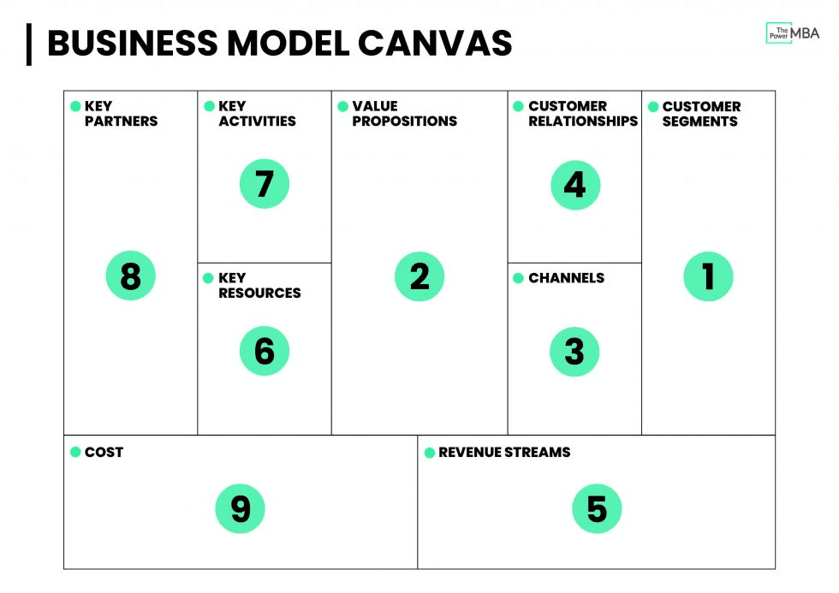
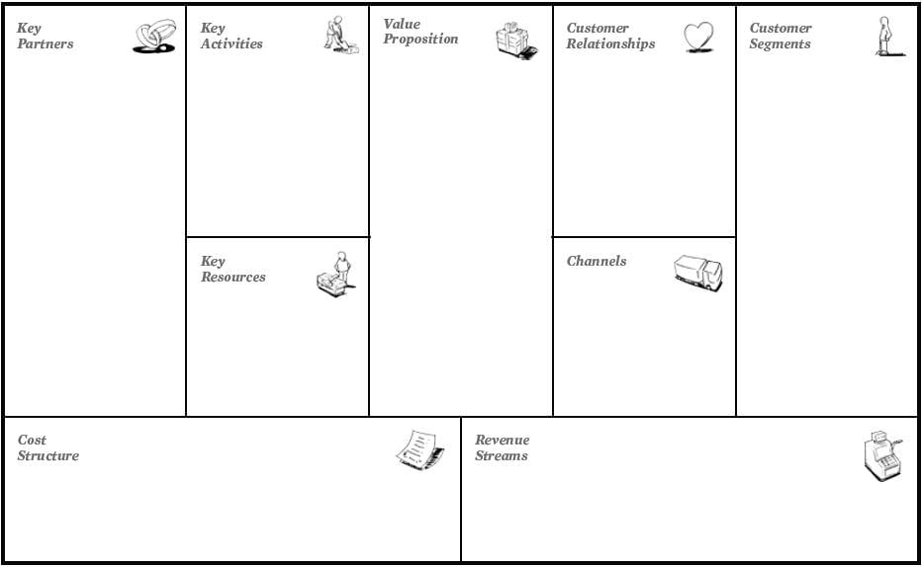

1. Key Activities → Operational Control
- Executives decide:
  - Which activities are core vs peripheral
  - What gets optimized, automated, outsourced, or eliminated
- This is where execution discipline and process authority live.
Control signal: “What must we do exceptionally well — and what can we ignore?”

2. Key Resources → Asset & Capability Control
- Executive authority determines:
  - Capital allocation
  - Talent concentration
  - IP ownership
- Control here decides organizational leverage.
Control signal: “What do we protect, starve, or over-invest in?”

3. Key Partnerships → Boundary Control
- Executives decide:
  - Vertical integration vs dependency
  - Strategic alliances vs arms-length contracts
- This block governs who controls what outside the firm.
Control signal: “What power do we keep — and what do we cede?”

4. Cost Structure → Constraint Control
- Budgets are a control technology.
- Executives impose discipline by:
  - Setting cost ceilings
  - Choosing efficiency vs redundancy
- This shapes organizational behavior more than any policy memo.
Control signal: “What pain are we willing to tolerate?”

5. Revenue Streams → Incentive Control
- Revenue logic determines:
  - Risk appetite
  - Time horizons
  - Ethical boundaries
- Incentives silently steer decisions at every level.
Control signal: “What behaviors get rewarded?”

6. Customer Segments & Value Proposition → Strategic Intent Control
- Executives decide:
  - Which customers matter
  - Which values are non-negotiable
- This is normative control — shaping purpose and identity.
Control signal: “Who do we exist for — and who do we exclude?”

What the Canvas Does Not Show (But Executives Care About)
Missing Dimension | Why It Matters
Decision rights | Who can override whom
Governance | Board vs management power
Ethics & constraints | What is forbidden, not just unprofitable
Learning & adaptation | How mistakes change future choices
Crisis authority | Who decides when rules break
These live outside the canvas — in culture, governance charters, and executive practice.

A Useful Reframe (Especially Given Your Interests)
You can think of the BMC as:
A metabolic map, not a nervous system
- It shows flows (value, money, activities)
- It hides agency, judgment, and executive cognition
If you wanted to add executive control explicitly, you’d introduce an overlay such as:
Executive Control Layer (Not in the Original Canvas)
- Strategic intent
- Decision rights
- Feedback loops
- Ethical constraints
- Crisis override authority
This mirrors your broader concerns about autonomy, governance, and control under complex systems — the same critique often applied to AI systems optimized without explicit executive judgment.

Prompt: Please, design a “Business Model Canvas +
Executive Control Overlay”
Response:
Below is a designed, usable framework you can actually teach, critique, or deploy:
Business Model Canvas + Executive Control Overlay (BMCEO)
This preserves Alexander Osterwalder’s original canvas but adds what it omits: judgment, authority, constraint, and learning.

1. Base Layer: Standard Business Model Canvas (Recap)

The original BMC answers:
- What value do we create?
- How do we deliver it?
- How do we capture it?
But it does not answer:
- Who decides?
- By what authority?
- Under what constraints?
- When rules can be broken?
- How learning feeds back into power?
That’s where the overlay comes in.

2. Executive Control Overlay — The Missing Nervous System
Think of this as a transparent layer placed over the canvas, not a replacement.
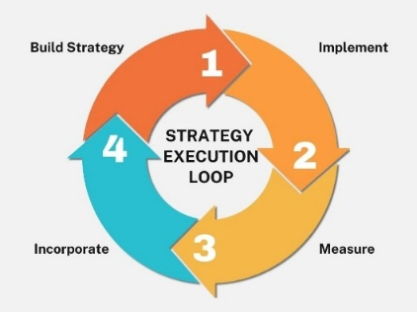
The Overlay Has 5 Control Domains

Control Domain I — Strategic Intent & Purpose
Placed above:
- Value Proposition
- Customer Segments
What it governs
- Mission
- Long-term horizon
- Moral boundaries
- Strategic exclusions (“we will not serve X”)
Executive questions
- Why do we exist beyond revenue?
- What success looks like if growth stalls?
- What tradeoffs are morally off-limits?
📌 Why it matters
Without this layer, optimization drifts into instrumental rationality (profit without meaning).

Control Domain II — Decision Rights & Authority
Placed at the center of the canvas
Explicitly defines:
- Who decides strategy?
- Who decides execution?
- Who can override algorithms, KPIs, or SOPs?
- Who decides in crisis?

Tool: RACI++ (Expanded)
Decision Type | Authority
Strategy | Board / Exec
Resource allocation | Exec
Operational changes | Management
Emergency override | Named humans
Ethical veto | Independent authority
📌 Why it matters
Most organizations assume decision rights — until something breaks.

Control Domain III — Resource & Constraint Governance
Overlaying:
- Key Resources
- Cost Structure
Adds:
- Capital allocation rules
- Budget ceilings as behavioral controls
- Redundancy vs efficiency choices
- Risk tolerance thresholds
Executive questions
- What do we intentionally underfund?
- Where do we accept inefficiency for resilience?
- What risks are unacceptable even if profitable?
📌 Key insight
Budgets are not financial tools — they are control technologies.

Control Domain IV — Incentives, Metrics & Behavioral Steering
Overlaying:
- Revenue Streams
- Key Activities
Makes explicit:
- Incentive alignment
- KPI selection
- Metric gaming risks
- Short-term vs long-term bias
Executive questions
- What behaviors are we rewarding unintentionally?
- Which metrics distort reality?
- What human judgment corrects metric failure?
📌 Warning
What you measure will eventually lie to you — unless bounded by judgment.

Control Domain V — Learning, Feedback & Adaptation
Placed beneath the entire canvas (feedback layer)
Governs:
- Post-mortems
- Model revision
- Strategy learning loops
- Institutional memory
Executive questions
- What evidence changes our mind?
- How do failures alter authority or process?
- What lessons survive leadership turnover?
📌 Key distinction
Learning ≠ data accumulation
Learning = changed decision rights or constraints

Full Stack View (Textual Diagram)
--------deleted--------

Why This Overlay Matters (Your Broader Theme)
This framework:
- Restores human judgment to optimization systems
- Makes power visible
- Prevents “AI-style drift” where:
  - Metrics replace meaning
  - Efficiency replaces wisdom
  - Growth replaces legitimacy
You could fairly describe the BMCEO as:
A liberal-education correction to managerial instrumentalism

Prompt: Cooperative and collective are alternatives to typical free market capitalists. How would their executive control overlay look?
Response:
Below is a comparative redesign of the Executive Control Overlay specifically for cooperatives and collectives, showing how they intentionally rewire power, authority, and judgment compared to free-market capitalist firms.
This is not a cosmetic change — it is a different theory of executive control.

Cooperative / Collective Executive Control Overlay (CC-ECO)
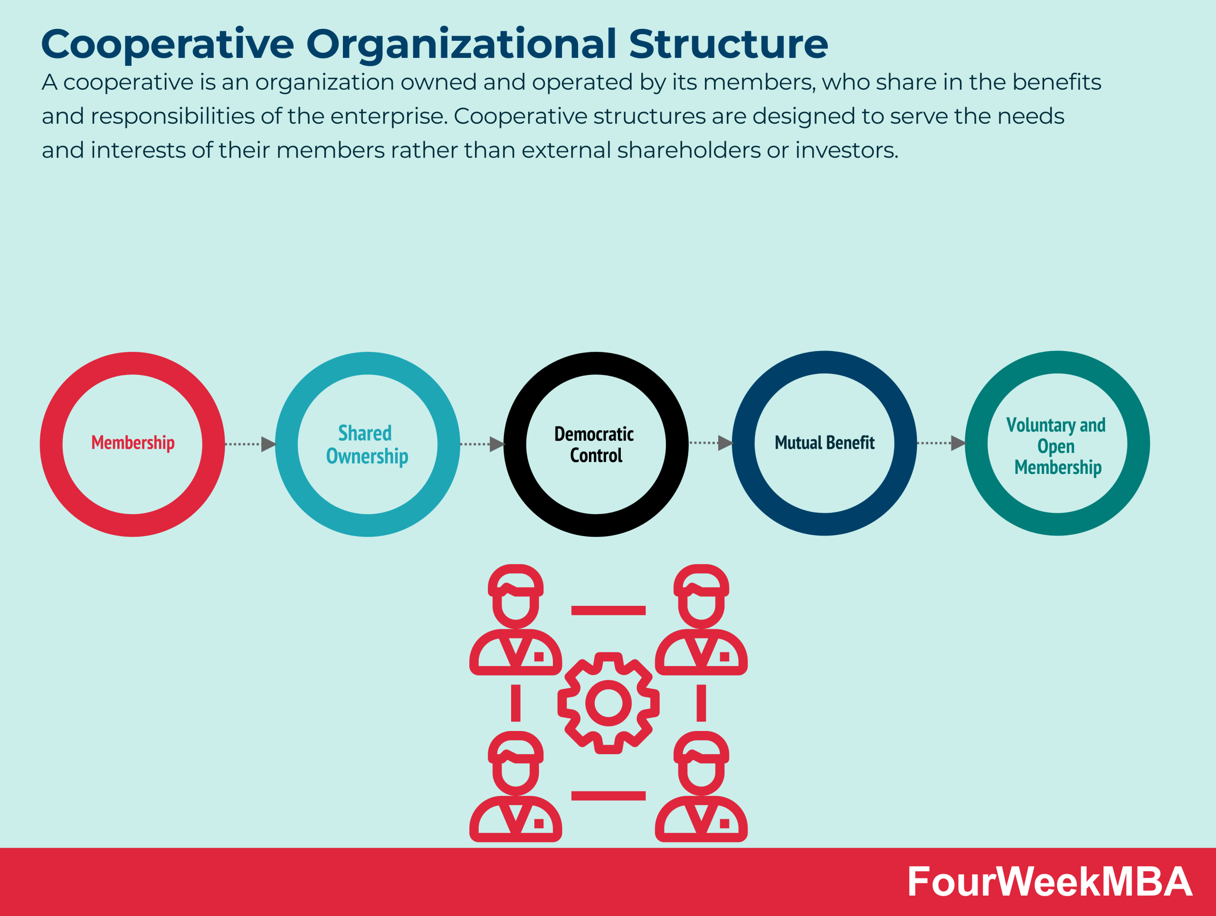

First: The Core Difference in One Sentence
Capitalist firms centralize executive control to protect capital.
Cooperatives distribute executive control to protect people and purpose.
The overlay therefore replaces unilateral authority with constitutional governance.

1. Strategic Intent & Purpose
(Owned by the Members, Not the Executives)
In cooperatives/collectives:
- Purpose is constitutionally defined
- Strategy must align with:
  - Member well-being
  - Community impact
  - Long-term viability
- Growth is conditional, not absolute
Control Mechanism
- Charter / bylaws
- Mission lock
- Member ratification for major pivots
📌 Control shift
From: Executive vision
To: Collective mandate
Strategy is something leaders interpret, not invent.

2. Decision Rights & Authority
(Polycentric, Layered, Recallable)
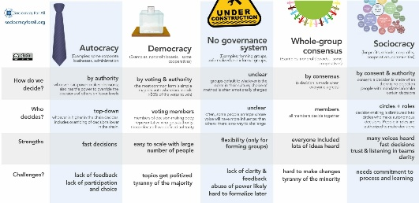
Authority is split across levels:
Decision Type | Authority Holder
Mission & values | General assembly
Strategic direction | Elected board
Operational execution | Managers / coordinators
Daily work decisions | Worker teams
Leadership legitimacy | Recallable by members
📌 Key innovation
- Leadership exists
- Executive authority is conditional and revocable
Executives are stewards, not sovereigns.

3. Resource & Constraint Governance
(Capital Is Instrumental, Not Supreme)
Capital rules change fundamentally:
- Capital is:
  - Patient
  - Capped
  - Subordinate to labor & purpose
- Profit = means, not end
Typical constraints:
- Pay ratios (e.g., 5:1 or 8:1)
- Reinvestment requirements
- Community reserves
- Crisis buffers
📌 Control signal
“What preserves the cooperative — not what maximizes return?”
This is why large cooperatives like Mondragon Corporation survived shocks that destroyed shareholder firms.

4. Incentives, Metrics & Behavioral Steering
(Solidarity Over Competition)
Metrics shift from:
- Individual performance → collective outcomes
- Growth → stability
- Speed → resilience
Common incentive designs:
- Profit-sharing by hours or role
- Team-level bonuses
- No stock options
- Limited variable pay
📌 Executive control here is negative
Executives remove perverse incentives rather than amplify rewards.
The goal is to prevent success from corrupting cooperation.

5. Learning, Feedback & Adaptation
(Deliberative, Not Algorithmic)
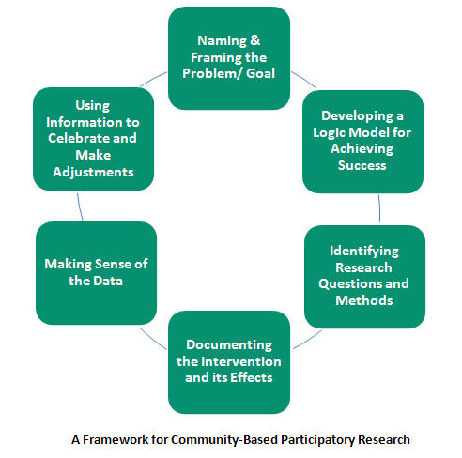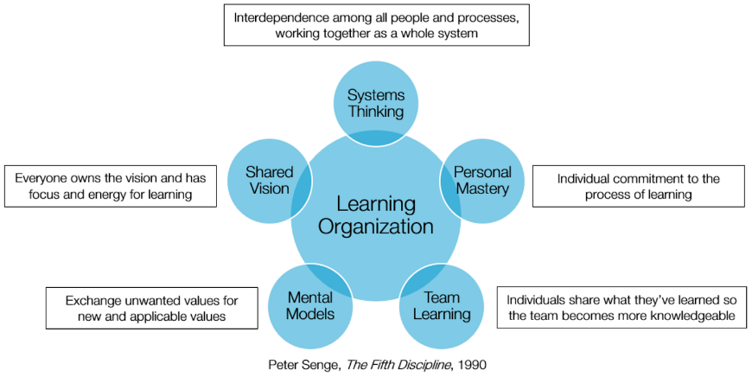
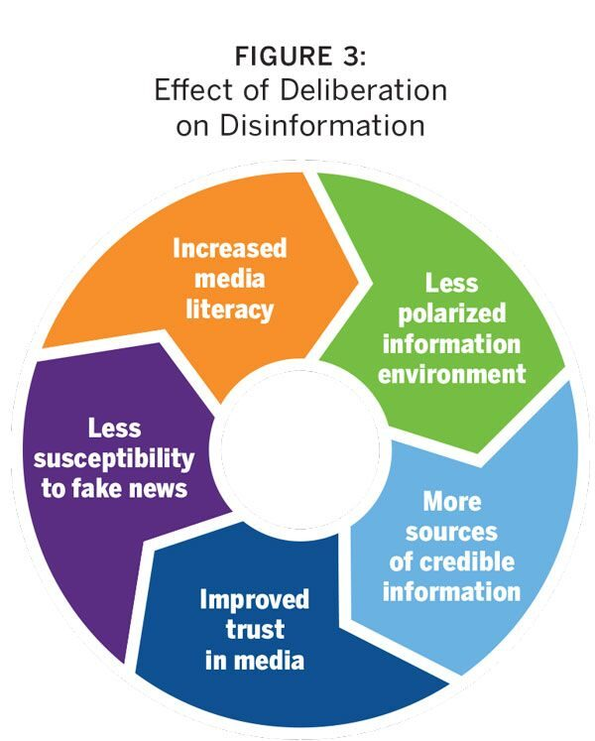
Learning happens through:
- Assemblies
- Retrospectives
- Open books
- Rotating leadership roles
Crucially:
- Learning changes rules, not just tactics
- Failures trigger:
  - Process revision
  - Role rotation
  - Governance reform
📌 Contrast with capitalism
- Capitalism adapts methods
- Cooperatives adapt authority structures

6. The Cooperative Executive Overlay — Full Stack
-------deleted---------

7. What Is Lost — Honestly
Cooperatives trade away:
- Rapid unilateral decision-making
- Extreme growth
- Speculative capital
- Charismatic executive dominance
This is not a bug.
It is the cost of democratic control.

8. What Is Gained
- Resilience
- Trust
- Lower burnout
- Higher legitimacy
- Ethical coherence
- Long-term survival
Cooperative executive control is anti-fragile rather than optimized.

9. Why This Matters for Your Broader Arc
This overlay directly answers the question:
How do we design systems where intelligence does not overpower judgment?
Which is the same question posed by:
- AI governance
- Platform capitalism
- University administration
- Civic institutions
Cooperatives are not nostalgic — they are prefigurative governance models.

Prompt: How would the revenue streams element of a business model canvas change if adopting to both cooperatives and collectives, but also the vision of the Pachamama Alliance?
Response:
Below is a precise redesign of the Revenue Streams block when a business model is shaped by (1) cooperatives, (2) collectives, and (3) the worldview of the Pachamama Alliance.
This is not a tweak.
It is a moral inversion of what revenue is for.

**Revenue Streams Reimagined:
Cooperative · Collective · Pachamama-Aligned**

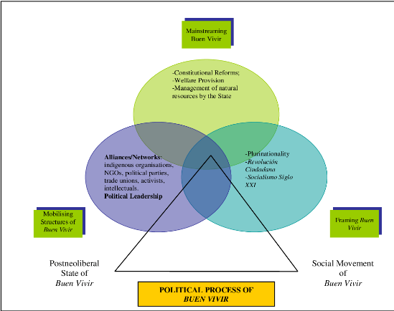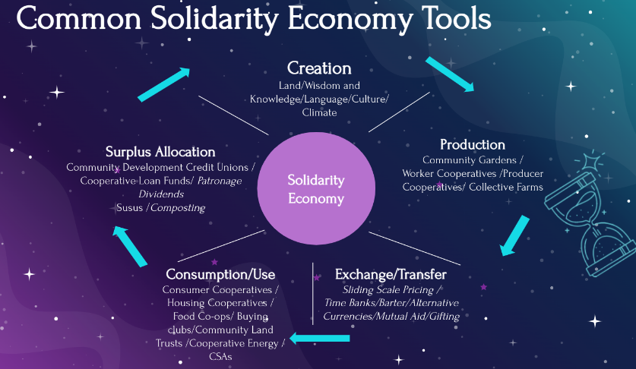

1. First: The Core Shift in Meaning
Capitalist BMC Assumption
Revenue = proof of success
More revenue = better organization
Cooperative + Pachamama Assumption
Revenue = nutrient flow
Enough revenue = organizational health
Revenue is no longer the goal
It is the circulatory system sustaining:
- people
- community
- land
- future generations
This aligns directly with the Andean concept of Buen Vivir (living well, not living more).

2. The Revenue Streams Block — Redefined
Old Question
How do we maximize revenue extraction?
New Questions
What forms of value exchange sustain life, dignity, and regeneration?
What revenue should we refuse, even if available?

3. Structural Changes to the Revenue Streams Element
A. Revenue Sufficiency Thresholds (Explicit Caps)
Instead of open-ended growth:
Question | Cooperative–Pachamama Answer
How much revenue is “enough”? | Defined democratically
What happens after sufficiency? | Reinvest, rest, regenerate
Is growth automatic? | No — it must be justified
📌 Control signal
“Growth must earn permission.”
This is a governance decision, not a market outcome.

B. Plural Revenue Types (Not Just Sales)
Revenue streams now include non-extractive flows:
Revenue Type |  | Purpose
Member contributions | Mutual commitment
Fair trade sales | Dignified exchange
Subscriptions | Stability, not lock-in
Sliding-scale pricing | Equity
Grants / commons funding | Stewardship
Reciprocity exchanges | Cultural legitimacy
Community reinvestment returns | Long-term resilience
Money is one medium among several.

C. Ethical Revenue Filters (Pre-Revenue Veto)
Before revenue is accepted, it passes through filters:
Does this revenue:
- Harm ecosystems?
- Undermine community autonomy?
- Create dependency or extraction?
- Violate intergenerational justice?
If yes → rejected, even if profitable.
📌 This is normative executive control, exercised by:
- members
- councils
- elders
- ethics committees

4. Distribution Replaces Accumulation
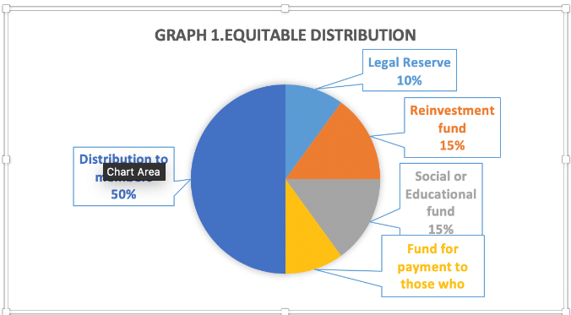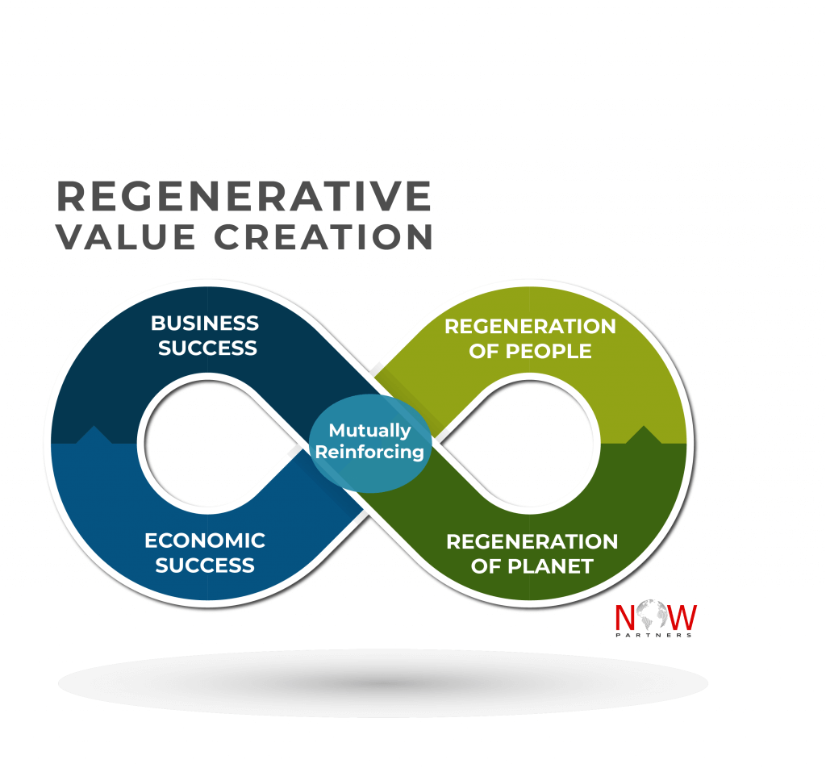
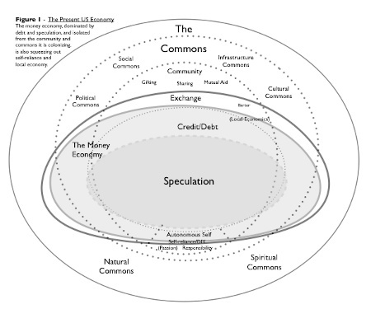

Revenue is immediately spoken for:
Allocation | Typical Share
Living wages & care | First claim
Community reinvestment | Mandatory
Ecological regeneration | Non-negotiable
Reserves (future shocks) | Required
Collective surplus | Democratically decided
📌 Key inversion
Profit is not what remains after costs —
Care is what remains after revenue arrives.

5. Time Horizon Shift: From Quarterly to Seventh Generation
Under Pachamama-aligned logic:
- Revenue is evaluated over:
  - ecosystems
  - cultural continuity
  - unborn members
- Fast money is high-risk money
- Slow revenue is trusted revenue
📌 This introduces temporal executive control:
Decisions must be defensible to people who cannot vote yet.

6. The New Revenue Streams Block (Rewrite)
Here is how the BMC Revenue Streams box would literally read:
Revenue Streams
Life-sustaining value flows that ensure:
- dignified livelihoods for members
- resilience of the community
- regeneration of land and ecosystems
- continuity across generations
Revenue is capped by sufficiency, filtered by ethics,
distributed by care, and governed democratically.

7. What This Forbids (Explicitly)
A Pachamama-aligned cooperative cannot rely on:
- Planned obsolescence
- Attention extraction
- Debt traps
- Artificial scarcity
- Externalized ecological harm
- Growth-dependent survival
If the model requires these → the model is invalid, not “challenging.”

8. Why This Is Radically Practical (Not Utopian)
Organizations aligned this way tend to show:
- Lower volatility
- Lower burnout
- Higher trust
- Stronger local resilience
- Moral legitimacy during crisis
They fail less catastrophically because they never bet everything on growth.

9. One-Sentence Summary
In a cooperative–collective–Pachamama model,
revenue is not extracted — it is welcomed, guided, shared, and returned.

Prompt: Issues of competition with other organizations, retirement of employees, and inflation must be accommodated. How?
Response:
This is the right stress test.
A Pachamama-aligned cooperative model only matters if it survives competition, aging, and inflation without betraying its values.
Below is a pragmatic accommodation framework that shows how these pressures are handled structurally, not hand-waved away.

Accommodating Competition, Retirement, and Inflation
Within Cooperative / Collective + Pachamama Economics
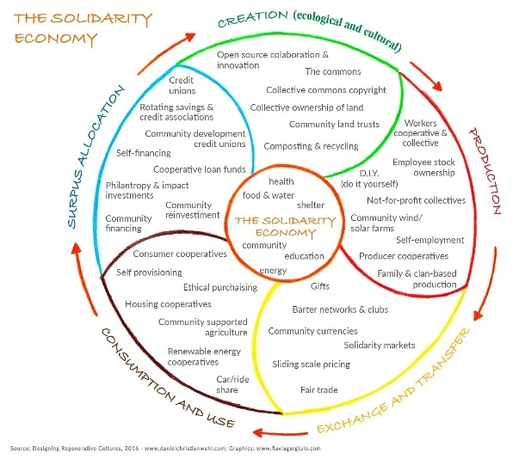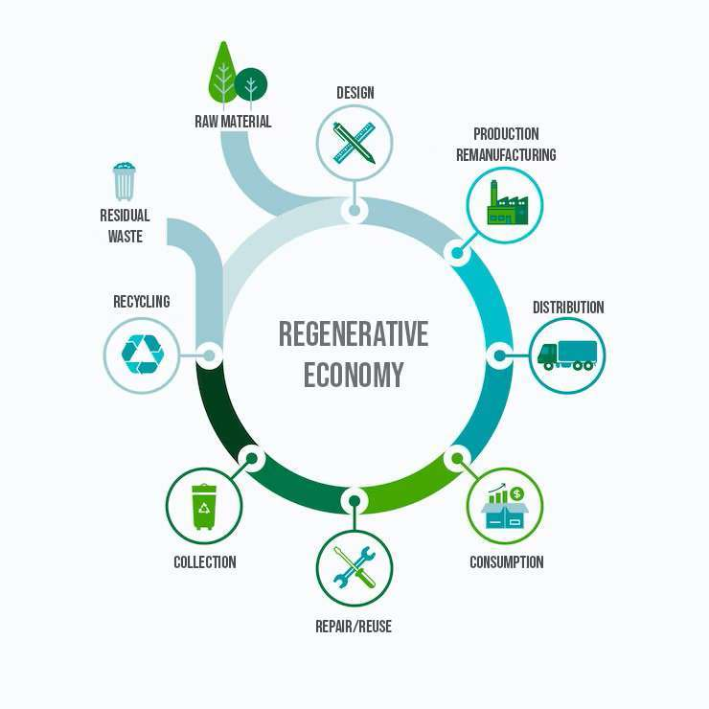

1. Competition
From Market Combat to Ecological Fitness
The Problem
Traditional competition assumes:
- Scarcity
- Winner-take-all dynamics
- Price undercutting
- Externalization of costs
This will destroy Pachamama-aligned values if adopted naively.

The Structural Solution: Competitive Sufficiency, Not Dominance
A. Compete on Integrity, Not Price
- Transparent pricing
- Ethical sourcing
- Durable products
- Community embeddedness
This attracts:
- Values-aligned customers
- Long-term partners
- Patient capital
- Institutional buyers
📌 The organization deliberately exits race-to-the-bottom markets.

B. Cooperate to Compete (Federation Logic)
Instead of isolated firms:
- Cooperatives form networks and federations
- Shared services:
  - insurance
  - logistics
  - accounting
  - R&D
  - legal defense
This mirrors ecosystems:
Species survive by niches + symbiosis, not by annihilation.
📌 Competition happens between ecosystems, not lone firms.

C. Anti-Growth Defense Mechanism
- Explicit refusal to scale beyond governance capacity
- Spin-offs instead of vertical expansion
- Knowledge sharing with “competitors”
This prevents:
- Cultural collapse
- Managerial capture
- Mission drift

2. Retirement & Aging
From Individual Burden to Intergenerational Covenant
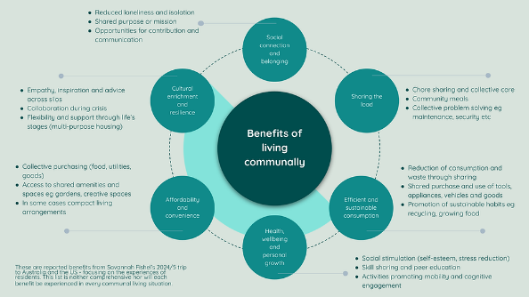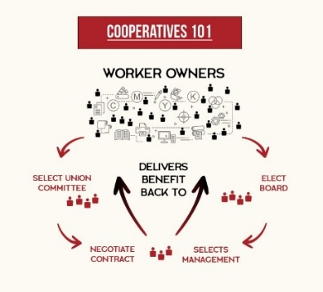
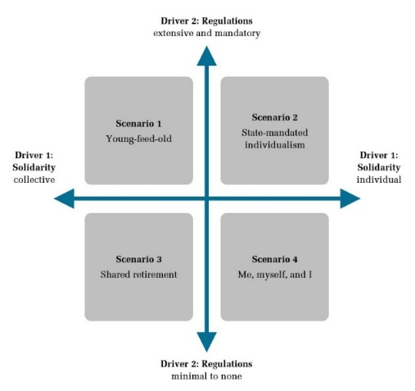
The Problem
Capitalist firms externalize retirement:
- 401(k) risk shifted to individuals
- Market volatility determines dignity
- Elders become “nonproductive costs”

The Structural Solution: Collective, Non-Speculative Security
A. Internal Solidarity Reserves
- Mandatory surplus allocation to:
  - retirement pools
  - health contingencies
- Managed conservatively
- No high-risk speculation
📌 Retirement becomes a shared responsibility, not a gamble.

B. Multi-Role Aging
Elders are not “retired away”:
- Mentorship
- Governance roles
- Training
- Cultural memory keepers
This preserves:
- Knowledge
- Identity
- Continuity
Productivity is redefined as contribution, not speed.

C. Portability Across the Ecosystem
- Retirement rights follow the person
- Recognized across cooperative federations
- Prevents lock-in or dependency
This mimics commons citizenship, not firm loyalty.

3. Inflation
Stability Through Structure, Not Financial Alchemy
The Problem
Inflation destroys:
- Fixed wages
- Savings
- Long-term planning
Capitalism “solves” this via:
- speculation
- financialization
- wage suppression

The Structural Solution: Adaptive Sufficiency
A. Indexing to Real Costs
- Wages indexed to:
  - housing
  - food
  - healthcare
  - energy
- Reviewed democratically
📌 Inflation is acknowledged explicitly, not hidden.

B. Internal Price Stabilization
- Long-term supplier relationships
- Local sourcing
- Cooperative purchasing pools
This dampens:
- price shocks
- supply volatility

C. Non-Monetary Value Buffers
When inflation spikes:
- Reduced hours instead of layoffs
- Increased time-off
- Shared services (food, childcare, transport)
These are anti-inflationary in lived experience, even if CPI rises.

4. How This Fits Pachamama’s Worldview
Aligned with the ethos of Pachamama Alliance:
Capitalist Assumption | Pachamama-Aligned Response
Competition is natural | Cooperation is natural
Aging is decline | Aging is stewardship
Inflation is technical | Inflation is relational
Growth solves risk | Balance absorbs shock
The goal is not immunity to hardship —
it is dignity under pressure.

5. Executive Control Adjustments (Critical)
To make all this work, executive control must:
- Prioritize resilience over optimization
- Allow slower but wiser decisions
- Accept lower peaks to avoid collapse
- Protect commons over margins
This is why AI-style optimization without judgment is dangerous in such systems.

6. One-Sentence Synthesis
Competition is not eliminated but civilized;
retirement is not outsourced but honored;
inflation is not denied but absorbed —
through structure, solidarity, and sufficiency.

Prompt: Compare the daily and long-term emotional, cognitive, and psychic attributes of workers at each level in a free-market capitalist organization to the attributes of an employee in a cooperative/collective.
Response:
Below is a phenomenological comparison—what it feels like, day-to-day and over a working life—to inhabit different positions in a free-market capitalist organization versus being a member-worker in a cooperative/collective.
This is not moralizing. It is structural psychology: how systems sculpt inner life.

Orientation: Two Different Human Experiments
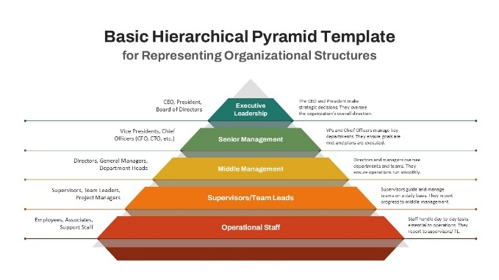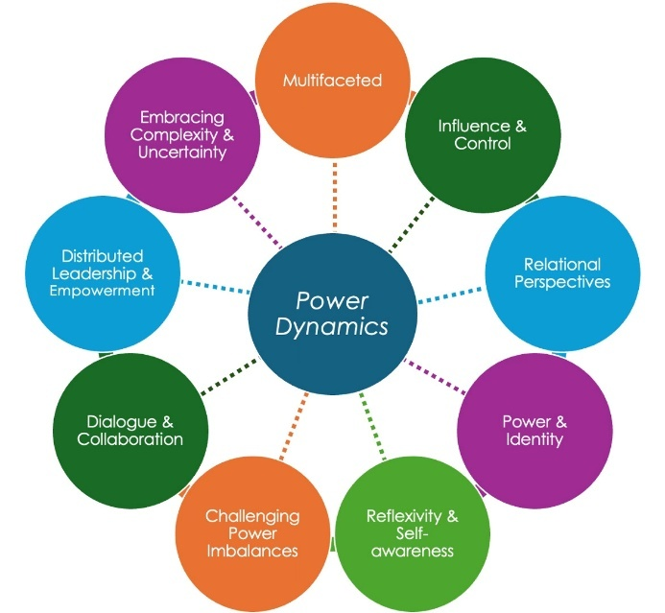
- Capitalist firms optimize for capital preservation and growth → inner life adapts to competition, precarity, and abstraction.
- Cooperatives/collectives optimize for human continuity and shared purpose → inner life adapts to responsibility, mutuality, and meaning.

I. Free-Market Capitalist Organization
(Inner life by hierarchical position)
1. Executive / C-Suite
Daily emotional state
- Chronic vigilance
- Controlled anxiety
- Performance intoxication mixed with isolation
- Low empathy bandwidth (by necessity, not cruelty)
Cognitive habits
- Abstraction over embodiment
- Metrics replace stories
- Strategic rationalization of harm (“necessary tradeoffs”)
- Overconfidence alternating with imposter syndrome
Psychic pattern (long-term)
- Splitting: public confidence / private emptiness
- Identity collapse after exit or failure
- Difficulty resting without guilt
- Meaning outsourced to legacy, power, or accumulation
Psychic signature: Sovereignty without belonging

2. Upper Management / Professional Class
Daily emotional state
- Anxiety disguised as busyness
- Fear of falling
- Conditional pride
- Moral dissonance (“I didn’t make the rules”)
Cognitive habits
- Translating human realities into KPIs
- Tactical compliance
- Attention fragmentation
- Risk aversion disguised as pragmatism
Psychic pattern (long-term)
- Burnout with benefits
- Cynicism without exit
- Loss of intrinsic motivation
- Quiet grief for abandoned ideals
Psychic signature: Responsibility without authority

3. Frontline / Wage Workers
Daily emotional state
- Precarity
- Low-grade fear
- Resentment mixed with dependency
- Emotional suppression
Cognitive habits
- Short-term survival focus
- Learned helplessness
- Rule-following over judgment
- Creativity as risk
Psychic pattern (long-term)
- Erosion of agency
- Somatic stress
- Diminished future imagination
- Internalized blame for structural failure
Psychic signature: Obedience without dignity

4. The Common Capitalist Throughline
Across all levels:
- Competition replaces solidarity
- Metrics replace meaning
- Speed replaces reflection
- Security is individualized
Result: Intelligence without wisdom, effort without fulfillment

II. Cooperative / Collective Organization
(The worker as member, steward, and co-author)
The Cooperative Member-Worker
(No caste differentiation—role differences exist, but dignity is flat)
Daily emotional state
- Groundedness
- Mutual accountability
- Lower anxiety baseline
- Occasional frustration without existential threat
Cognitive habits
- Systems thinking
- Long-term orientation
- Practical moral reasoning
- Comfort with complexity and deliberation
Psychic pattern (long-term)
- Stable identity
- Preserved agency into old age
- Capacity for rest without shame
- Meaning rooted in contribution, not status
Psychic signature: Belonging with responsibility

What Changes Most Profoundly
1. Anxiety Location
- Capitalism: internalized (“What if I fail?”)
- Cooperative: externalized and shared (“How do we respond?”)
2. Time Perception
- Capitalism: future as threat or prize
- Cooperative: future as obligation
3. Moral Injury
- Capitalism: frequent, normalized, unspoken
- Cooperative: rarer, discussed, reparable
4. Sense of Self
- Capitalism: self = role + performance
- Cooperative: self = member + contributor

Side-by-Side Summary Table
Dimension | Capitalist Worker | Cooperative Member
Emotional baseline | Anxiety | Groundedness
Cognitive style | Instrumental | Deliberative
Agency | Conditional | Inherent
Competition | Internalized | Contextualized
Meaning | Deferred | Immediate
Aging | Threat | Transition
Failure | Personal | Collective
Rest | Guilt-laden | Legitimate

The Deepest Difference (Often Missed)
Capitalist systems assume:
Humans must be motivated by fear or reward
Cooperative systems assume:
Humans must be trusted with responsibility
These assumptions literally sculpt different nervous systems over time.

Final Synthesis
A free-market capitalist organization produces
clever, anxious, fragmented selves at every level.
A cooperative or collective produces
capable, accountable, integrated persons—
fewer highs, far fewer collapses.
This is why your earlier concern about AI-style optimization without judgment is so central: it accelerates the capitalist psychic pattern unless explicitly constrained.

Prompt: compare Nordic social democracy vs Mondragon vs co-ops vs US capitalism
Response:
Below is a clean, structural comparison of Nordic social democracy, Mondragon Corporation, co-ops (general), and US free-market capitalism—focused on governance, security, incentives, and the inner life of work.
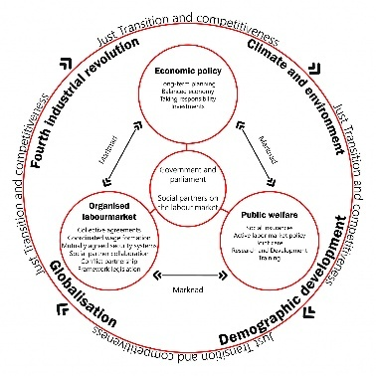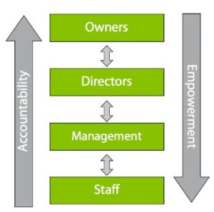
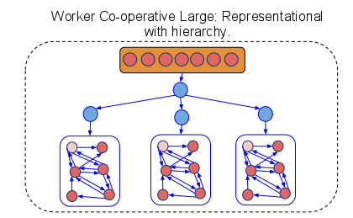

One-Sentence Snapshot
- US capitalism: Markets rule; people adapt.
- Nordic social democracy: Markets operate; the state cushions.
- Co-ops (general): People own work; markets are negotiated.
- Mondragon: People own work at scale—with constitutional discipline.

1) Governance & Power
Dimension | US Capitalism | Nordic Social Democracy | Co-ops (General) | Mondragon
Ownership | Shareholders | Shareholders | Workers/members | Workers via federated co-ops
Ultimate authority | Capital | Capital + State | Members | Members + federation
Decision rights | Top-down | Top-down (tempered) | Democratic | Democratic, layered
Executive accountability | Board/markets | Board + law | Recallable | Recallable, constitutional
Key difference:
Nordic systems don’t change firm power; they counterbalance it.
Mondragon rewires firm power itself.

2) Economic Security (Illness, Job Loss, Aging)
Dimension | US Capitalism | Nordic | Co-ops | Mondragon
Healthcare | Employer/market | Universal | Varies | Integrated mutuals
Unemployment | Minimal | Strong | Internal solidarity | Internal transfers
Retirement | Individualized | Public + private | Collective reserves | Cooperative pension system
Risk location | Individual | State | Collective | Collective, federated
Interpretation:
Nordic security is external (state).
Mondragon security is internal (the enterprise ecosystem).

3) Incentives, Pay, and Competition
Dimension | US Capitalism | Nordic | Co-ops | Mondragon
Pay dispersion | Very high | Moderate | Low–moderate | Capped (historically ~5–8:1)
Incentives | Individual, financial | Individual + social | Collective | Collective + role-based
Competition | Zero-sum | Regulated | Cooperative-competitive | “Cooperate to compete”
Growth logic | Maximize | Balance | Sufficiency | Viability over dominance
Crucial point:
Nordic countries civilize competition; Mondragon replaces its logic inside the firm.

4) Innovation & Scale
Dimension | US Capitalism | Nordic | Co-ops | Mondragon
Innovation speed | High (volatile) | High (stable) | Variable | High (patient)
Scale | Massive | Massive | Usually, small | Large (100k+ workers)
Failure mode | Catastrophic | Buffered | Fragmentation | Internal reallocation
Reality check:
Mondragon disproves the claim that democracy can’t scale—but only with federation, discipline, and limits.

5) Daily & Long-Term Inner Life of Workers (Synthesis)
Dimension | US Capitalism | Nordic | Co-ops | Mondragon
Daily affect | Anxiety, speed | Calm, protected | Grounded | Grounded + purposeful
Agency | Conditional | Externalized (state) | Internal | Internal + collective
Moral injury | Normalized | Reduced | Discussed | Actively managed
Identity | Role-performance | Citizen-worker | Member-worker | Steward-worker
Aging | Threat | Secured | Honored | Integrated
Deep insight:
- Nordic systems protect the citizen.
- Co-ops protect the worker.
- Mondragon protects the person-in-community inside production.

6) Where Each Model Breaks
- US capitalism: burnout, inequality, legitimacy crises.
- Nordic social democracy: dependent on strong state capacity; firm power
remains extractive.
- Co-ops (general): fragile at scale; vulnerable to market pressure.
- Mondragon: slower decisions; cultural demands are high; requires
constant education.
No model is free of tradeoffs.

7) Choosing the Model Depends on the Question
- Want maximum innovation speed? → US capitalism (with damage).
- Want social peace without changing firms? → Nordic model.
- Want dignity at work? → Co-ops.
- Want dignity at scale? → Mondragon-style federation.

Final Synthesis (The One That Matters)
Nordic social democracy humanizes capitalism from the outside.
Mondragon humanizes it from the inside.
In an era of AI-driven optimization, that distinction is decisive:
systems that leave firm power untouched will eventually be outpaced by extraction logic.
Systems that constitutionalize human judgment inside organizations are more future-proof.

Prompt: This better world, incarnate as cooperatives, collectives, syndicates, and federations; depends on a set of ethical, value-laden, and knowledge and skills of everyone involved in making this world happen. Articulate what these are.
Response:
What you’re naming is not an institutional design problem alone but a civilizational competence problem.
Cooperatives, collectives, syndicates, and federations only work if the people inside them become a different kind of human-in-relation. Below is a clear articulation of the ethical commitments, value orientations, and shared skills required to make such a world stable rather than fragile.

Orientation: This Is a Moral-Technical Ecosystem
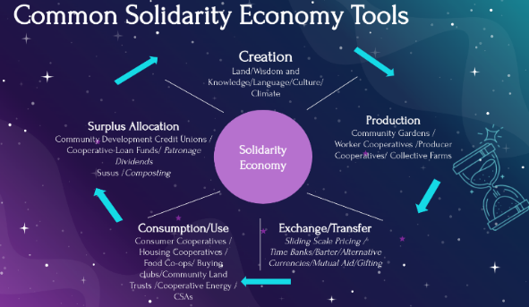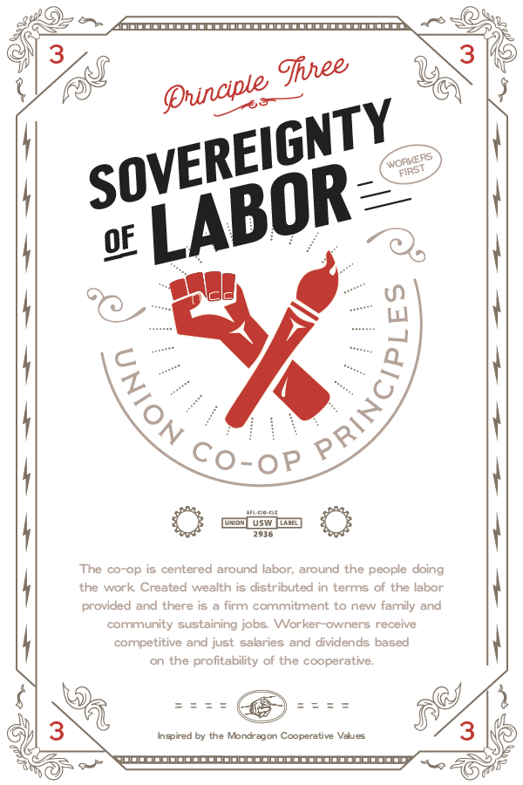

These forms do not succeed by incentives alone.
They require trained moral perception, civic maturity, and collective intelligence.

I. Ethical Foundations
(What must be treated as non-negotiable)
These are constraints, not aspirations.
1. Human Dignity Is Prior to Efficiency
- People are never “resources”
- No one is disposable for optimization
- Speed never justifies humiliation or harm
This ethic blocks AI-style instrumental rationality at the root.

2. Reciprocity Over Extraction
- Value is co-created, not seized
- Taking without replenishing is theft—even if legal
- Power must circulate or it corrupts
This ethic comes directly from Indigenous cosmologies such as those championed by the Pachamama Alliance, where imbalance is understood as pathology.

3. Intergenerational Responsibility
- Decisions must be defensible to:
  - elders
  - children
  - the unborn
- Short-term gain that forecloses future choice is unethical
This introduces time as a moral dimension, not just a planning variable.

4. Truthfulness Under Conditions of Power
- No strategic lying to members
- No “necessary opacity” to maintain control
- Bad news must travel faster than good news
Without this ethic, democracy collapses into theater.

II. Core Values
(What people must positively care about)
Values shape daily behavior, not mission statements.

1. Shared Fate
- “If this fails, we fail together”
- “If this succeeds, we share the surplus”
- No moral exit ramps for insiders
This value replaces fear-based motivation with mutual seriousness.

2. Sufficiency Instead of Maximization
- Enough is a real, discussable number
- More is not automatically better
- Rest, slack, and redundancy are virtues
This value directly counters growth addiction.

3. Belonging Without Possession
- The organization is not “mine”
- Membership implies stewardship, not control
- Leadership is temporary custody
This prevents charismatic capture and founder pathology.

4. Conflict as Information
- Disagreement is not disloyalty
- Tension signals system learning
- Suppressed conflict is more dangerous than open conflict
This value underwrites resilience.

III. Essential Knowledge
(What everyone must understand, at least at a basic level)
These are civic literacies, not elite expertise.

1. Economic Literacy (Non-Ideological)
- How money flows
- Where value is actually created
- What tradeoffs are real vs imagined
- How debt, inflation, and capital work
Without this, democracy becomes symbolic and manipulable.

2. Power & Governance Literacy
- Who decides what
- How authority is delegated
- How decisions can be challenged
- How leaders are removed
People must understand governance the way citizens understand law.

3. Ecological Systems Thinking
- Limits
- Feedback loops
- Regeneration vs depletion
- Irreversibility
This prevents treating the world as a warehouse.

4. Historical Consciousness
- How cooperatives fail
- How revolutions decay
- How institutions are captured
- How good intentions are corrupted
Memory is a defensive technology.

IV. Core Skills
(What people must be able to do, repeatedly, under pressure)
This is where most experiments fail.

A. Intrapersonal Skills (Self-Governance)
1. Affect Regulation
- Tolerating frustration
- Managing resentment
- Not externalizing anxiety onto others
Without this, meetings become emotional battlegrounds.

2. Ego Decentering
- Holding influence without domination
- Being wrong publicly
- Letting ideas die without taking it personally
This skill is rare—and essential.

B. Interpersonal Skills (Relational Governance)
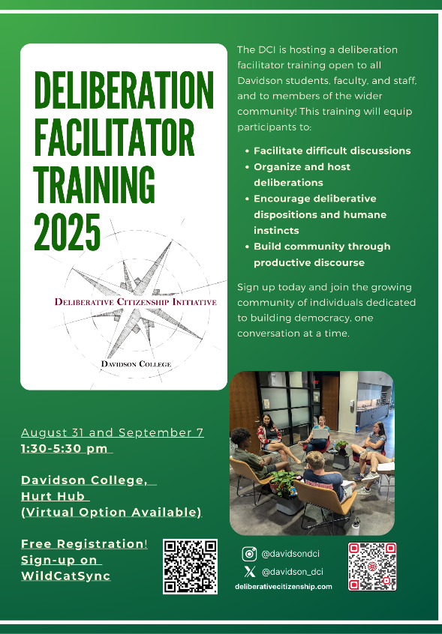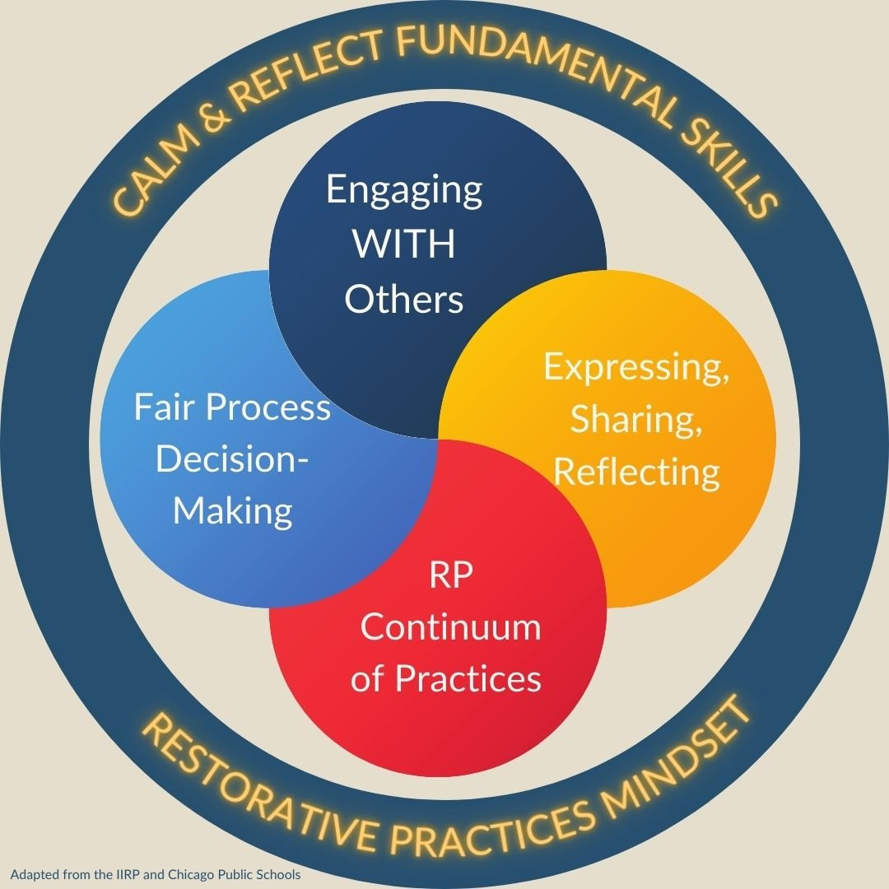

3. Deliberation
- Listening to understand, not to win
- Integrating minority positions
- Distinguishing veto from preference

4. Conflict Repair
- Naming harm without moral theater
- Making restitution
- Rebuilding trust after rupture
Conflict resolution is not a soft skill—it is infrastructure.

C. Collective Skills (System Stewardship)
5. Decision-Making Under Uncertainty
- Acting without full information
- Revising decisions without blame
- Separating identity from outcome

6. Role Fluidity
- Leading when needed
- Following when appropriate
- Letting go when the moment passes
This is the opposite of careerism.

V. The Hidden Requirement: Continuous Education
Cooperative worlds do not emerge once.
They must be re-taught every generation.
Successful federations:
- invest heavily in education
- rotate roles intentionally
- ritualize learning
- treat civic formation as ongoing work
Without this, the system regresses to hierarchy.

VI. The Hard Truth (Stated Clearly)
These worlds fail not because humans are selfish,
but because we have been trained for domination, competition, and passivity.
Building cooperative futures requires retraining the nervous system, not just rewriting bylaws.

Final Synthesis
A cooperative civilization is not built by better rules alone, but by ethically serious, psychologically mature, economically literate, and relationally skilled people
who accept responsibility for one another and for the future.
That is not utopian.
It is demanding—which is why it works when it does.

Please create a set of references for the topics in this conversation, each with a brief narrative description format in Chicago style.
Below is a curated reference list in Chicago (Notes & Bibliography) style with brief narrative descriptions. These sources directly support the major themes of the conversation: executive control, cooperative governance, Nordic social democracy, AI limits, and liberal education.

Selected References with Annotations (Chicago Style)
Association of American Colleges and Universities (AAC&U). College Learning for the New Global Century. Washington, DC: AAC&U, 2007.
A foundational statement of the LEAP Essential Learning Outcomes. Argues that ethical reasoning, integrative learning, and civic knowledge are central to preparing students for complex democratic and economic systems—core to the executive judgment capacities discussed in this conversation.
Beer, Stafford. Brain of the Firm. 2nd ed. Chichester, UK: Wiley, 1981.
A classic cybernetic analysis of organizational control systems. Beer’s Viable System Model helps explain the distinction between operational metabolism and executive control, providing a systems-theory backbone for the Executive Control Layer concept.
Deresiewicz, William. Excellent Sheep: The Miseducation of the American Elite. New York: Free Press, 2014.
Critiques elite education for producing high-performing but risk-averse graduates. Supports the conversation’s concern that technical training without moral and civic formation weakens institutional leadership.
Freire, Paulo. Pedagogy of the Oppressed. New York: Continuum, 1970.
Introduces conscientização (critical consciousness), emphasizing education as preparation for democratic agency rather than passive role performance—highly aligned with cooperative and civic governance themes.
Hinton, Geoffrey. “The Risks of Artificial Intelligence.” Various interviews and lectures, 2023–2024.
Hinton’s public warnings about advanced AI systems highlight the gap between computational capability and human-aligned judgment, reinforcing the need for human executive oversight.
Mazzucato, Mariana. The Value of Everything: Making and Taking in the Global Economy. New York: PublicAffairs, 2018.
Distinguishes value creation from value extraction. Provides an economic critique supporting cooperative and Pachamama-aligned models of revenue and purpose.
Mondragon Corporation. Annual Report. Mondragón, Spain: Mondragon Corporation, various years.
Primary documentation of the world’s largest worker cooperative federation. Demonstrates the feasibility of democratic governance at scale and informs comparisons made in this discussion.
Osterwalder, Alexander, and Yves Pigneur. Business Model Generation. Hoboken, NJ: Wiley, 2010.
Introduces the Business Model Canvas. Serves as the baseline framework that this conversation extends through the Executive Control Overlay.
Ostrom, Elinor. Governing the Commons: The Evolution of Institutions for Collective Action. Cambridge: Cambridge University Press, 1990.
Nobel Prize–winning analysis of how communities successfully manage shared resources. Provides empirical grounding for cooperative and federated governance structures.
Roth, Michael S. Beyond the University: Why Liberal Education Matters. New Haven, CT: Yale University Press, 2014.
Defends liberal education as preparation for adaptive judgment in complex societies. Strongly supports the AAC&U alignment emphasized in the discussion.
Sabel, Charles F., and Jonathan Zeitlin. “Learning from Difference: The New Architecture of Experimentalist Governance in the EU.” European Law Journal 14, no. 3 (2008): 271–327.
Explores iterative, feedback-driven governance models that parallel cooperative learning systems and AI-augmented organizational adaptation.
Sen, Amartya. Development as Freedom. New York: Knopf, 1999.
Frames economic development around human capabilities rather than GDP growth, aligning closely with cooperative and sufficiency-oriented economic models.
Standing, Guy. The Precariat: The New Dangerous Class. London: Bloomsbury Academic, 2011.
Analyzes insecurity in contemporary labor markets, providing sociological context for the psychological comparisons between capitalist and cooperative work environments.
Zuboff, Shoshana. The Age of Surveillance Capitalism. New York: PublicAffairs, 2019.
Documents how data-driven firms optimize behavior at scale. Offers a critical backdrop for concerns about AI-driven incentive systems and the erosion of human autonomy.

